Hartlepool CC May 2020 PDI – Dora Davies Memorial – Judges Comments

Thank you for inviting me to judge your Dora Davies Memorial Competition!
A mammoth entry, well done! A large variety of images with some superb quality and artistic style. You have made it very hard to judge! But I have enjoyed it thoroughly, especially during these lock down times. The top three images are at the end of the feedback, I have chosen what may appear to be a large amount of Highly Commended images, but this is a large entry, and the standard warrants this. There are nine HC’s which are announced in order of presentation.
Well done to everyone who entered, and may you enjoy your photography even more once we are back to normal!
Kind Regards
Peter Walton
NCPF Judge ~ 7th May 2020

A lonely  Bluebell  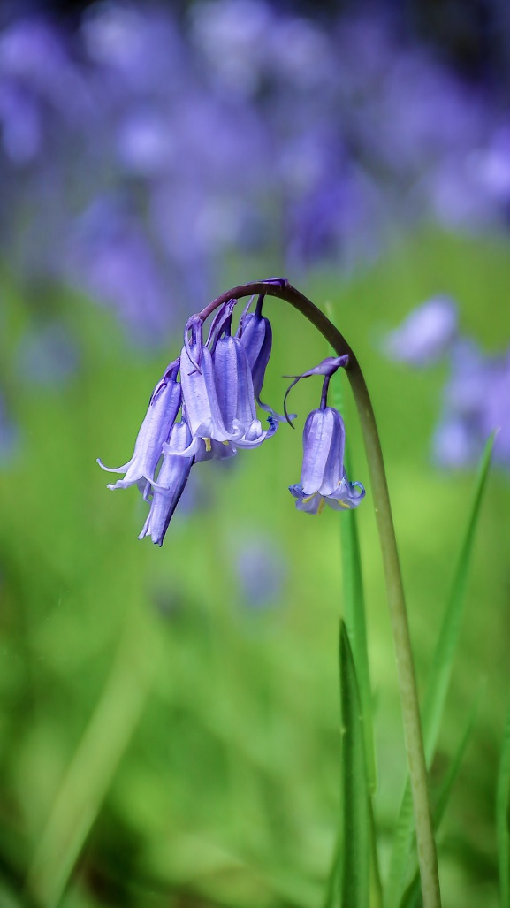 | Seasonal image, the flower of May, but not lonely, in context, well positioned camera, blue background a supportive feature. Good exposure, composition, angle and good light. HIGHLY COMMENDED
A night on the Tyne  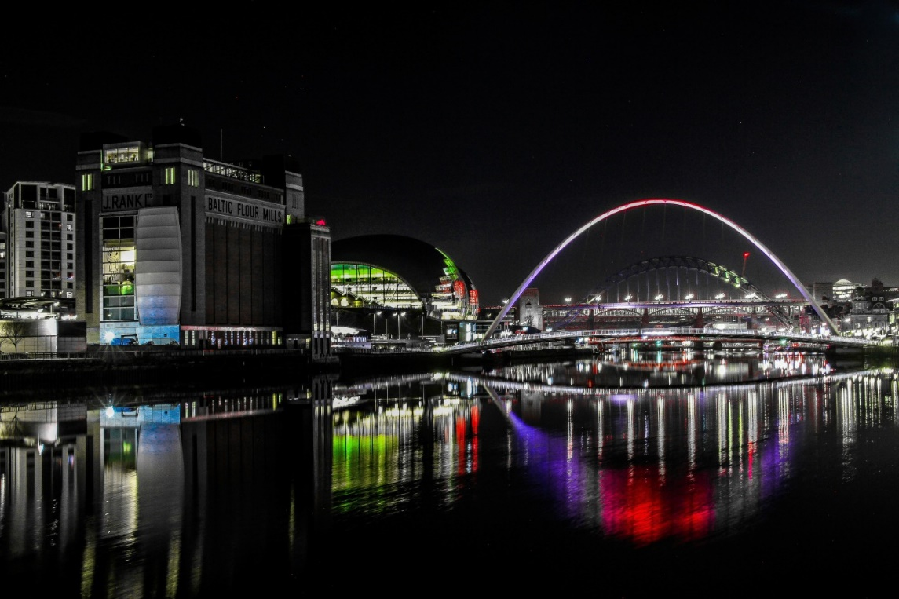 | I’m a Newcastle Lad; this is still an amazing place for a night  out, with or without a camera! A well exposed monochromatic image with splashes of colour where appropriate, it works well and has what could be a distinct patent to it. Detail in the right places, pattern and style.
American dispatch rider  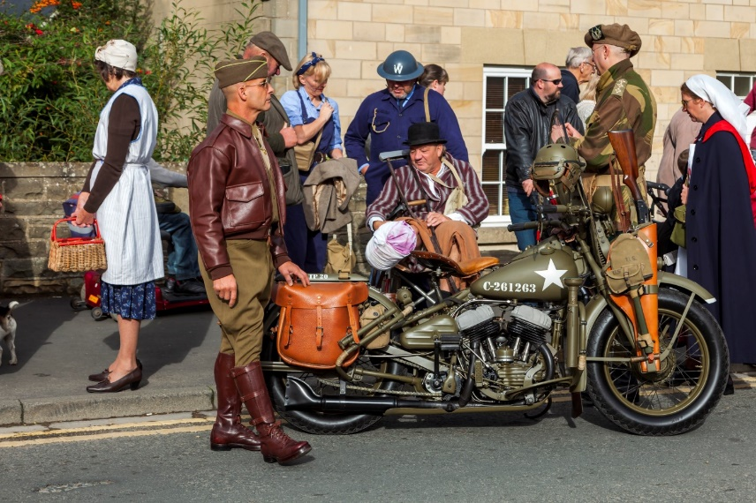 | So much going on in this picture, but the dispatch rider dominates to a degree with his disciplined appearance and deportment. He clearly likes his leather, and his hand on the satchel indicates a pride in his pastime. However, perhaps a closer view of the subject matter would stop your eyes wandering into the other activity taking place in the picture.  Sharp and well exposed.

Arabian Nights  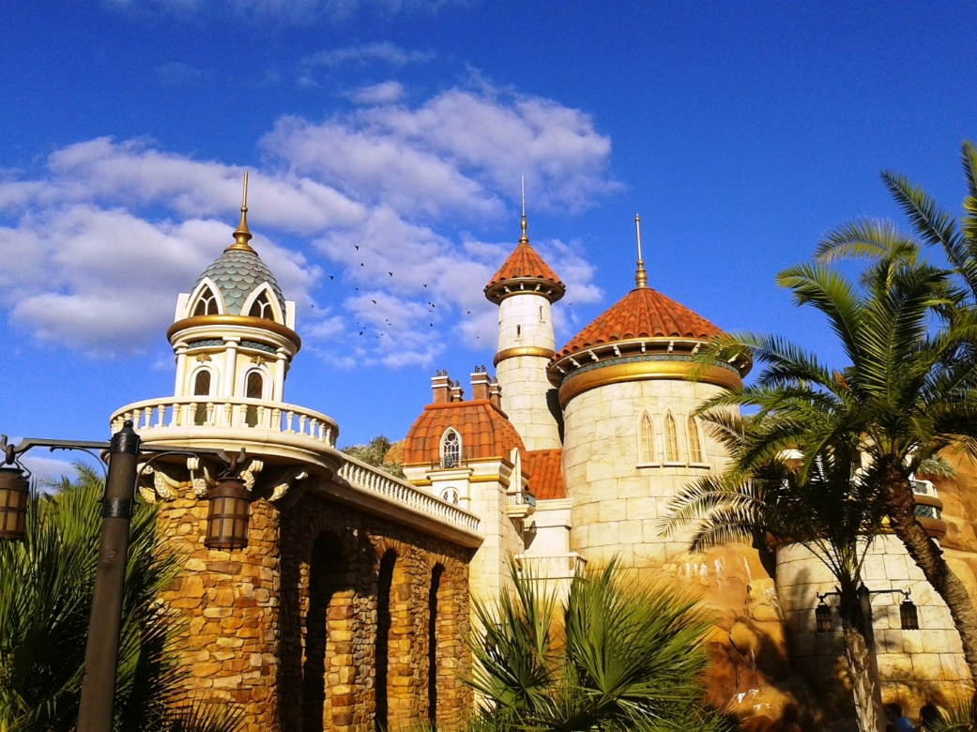 | A collection of interesting buildings and roofs taken on a lovely day. Sharp, well exposed, makes me inquisitive as to where it is and what it represents, interesting architecture and a flock of birds arriving just in time for the picture. The title leaves me looking for Knights though.
Autumn in the park  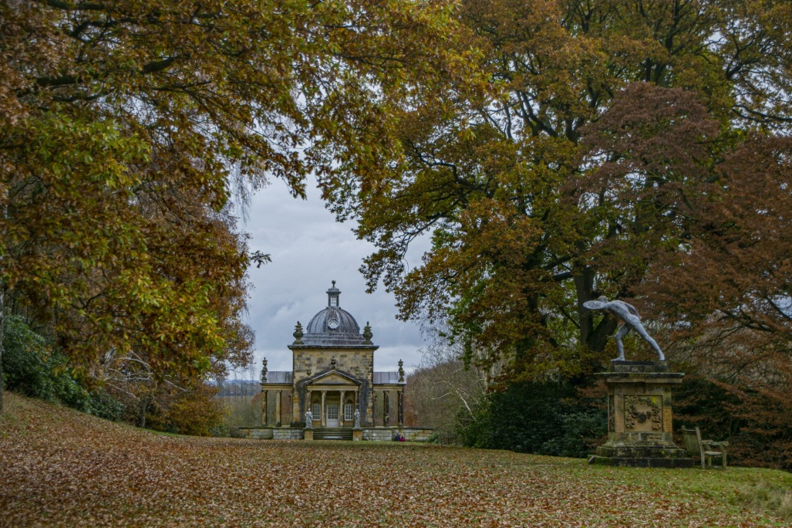 | Not completely alone, but the author has managed to capture a really interesting place in its autumnal beauty and style. The figurine is powerful in its pose and pulls the eye away from an interesting building. Pleasant image
Babbling Brook  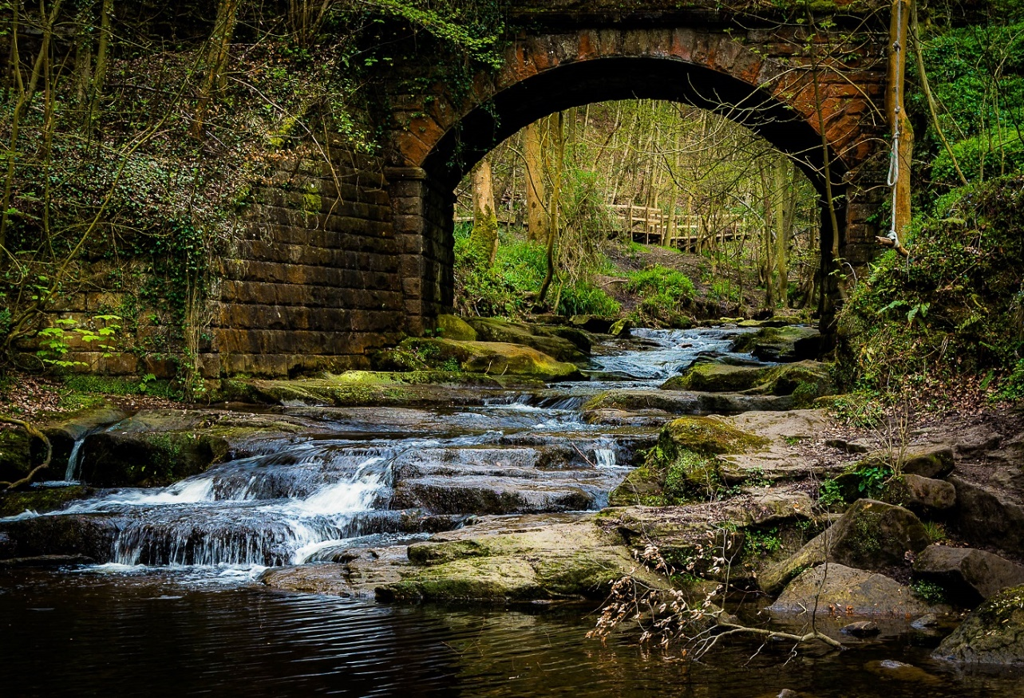 | Quite a calming view of a babbling brook descending in a soothing way over the rocks. Stonework on bridge introduces a feature to the background, diagonal flow of water through the picture works well. Nicely exposed, just a hint of soft water in the choice of shutter speed.
Barn Owl  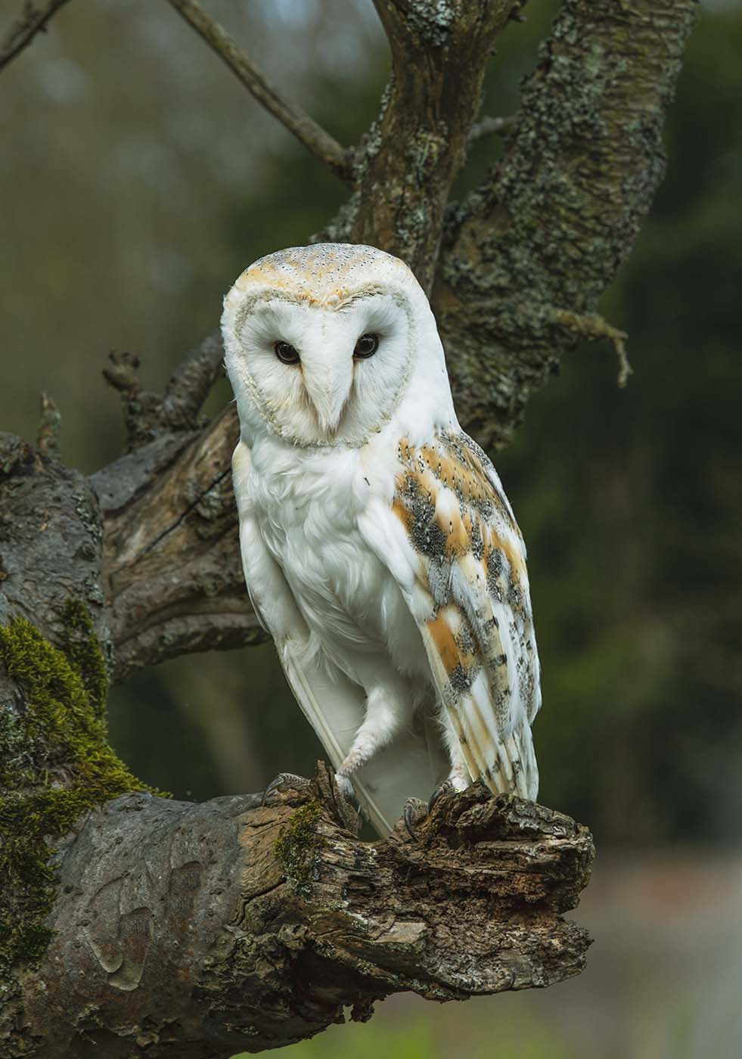 | Good composition is my first observation. Wild life is so difficult, but author has scored here with the choice of tree, and the position of the barn owl, well done. Good choice of aperture with only the important bits being sharp.
Between a rock and a hard place  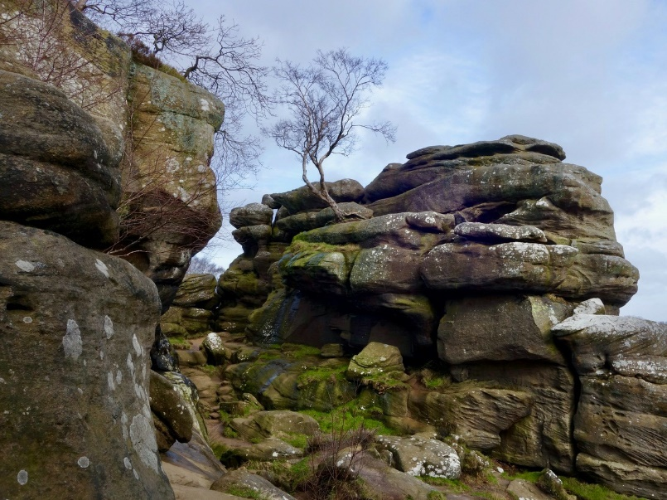 | Perhaps Brimham Rocks? Many shapes and angles to photograph in the powerful gritstone shapes, softened by the trees clinging onto soil where they can. Like the way the green moss has been captured moving its way down the rocks.
Black Rock Cottage  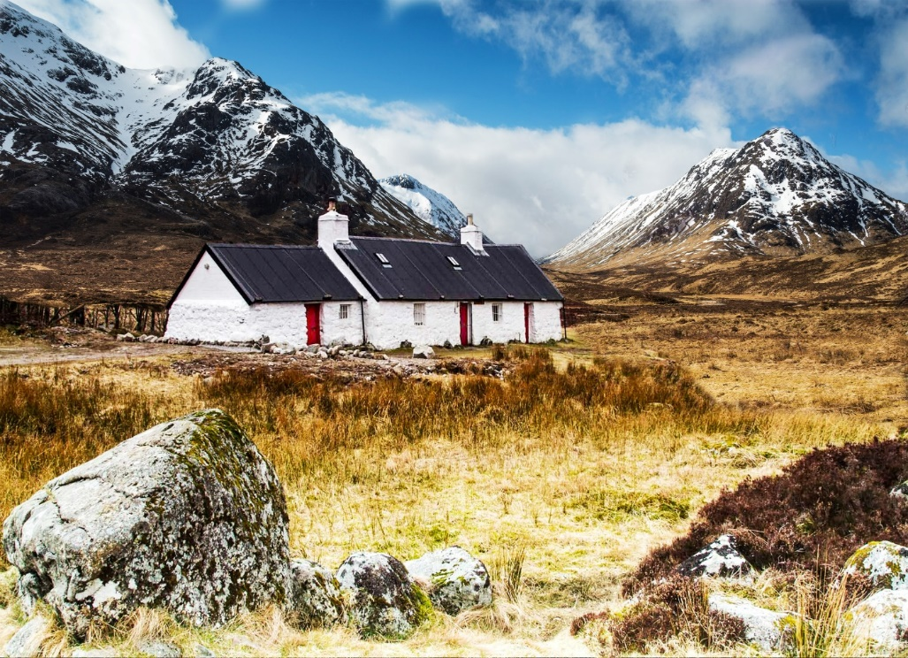 | The famous climbing hut in Glencoe. Good composition, with the two foreground rocks echoing the mountains in the background giving the picture balance. The author has been blessed with good weather for this shot; however, I feel more detail could have been achieved in the foreground which is burnt out in parts.
Boulders in the stream  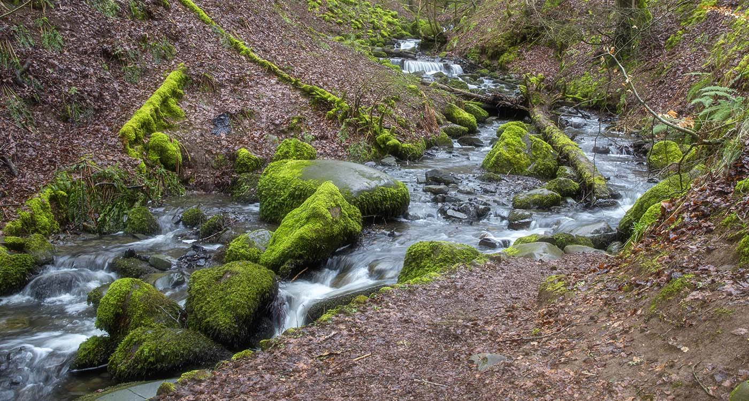 | The moss growing on the logs and rocks give this picture character. A slow shutter speed has given a softness to the water, just enough. The bend in the stream adds to the picture composition well.
Buttermere  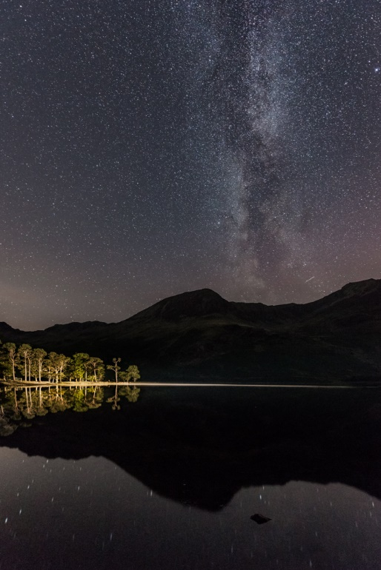 | A carefully composed night shot near the Buttermere pines including a beautiful star collection above. The illumination and exposure of the main features has been handled very well. A well balanced composition.
Cascading water  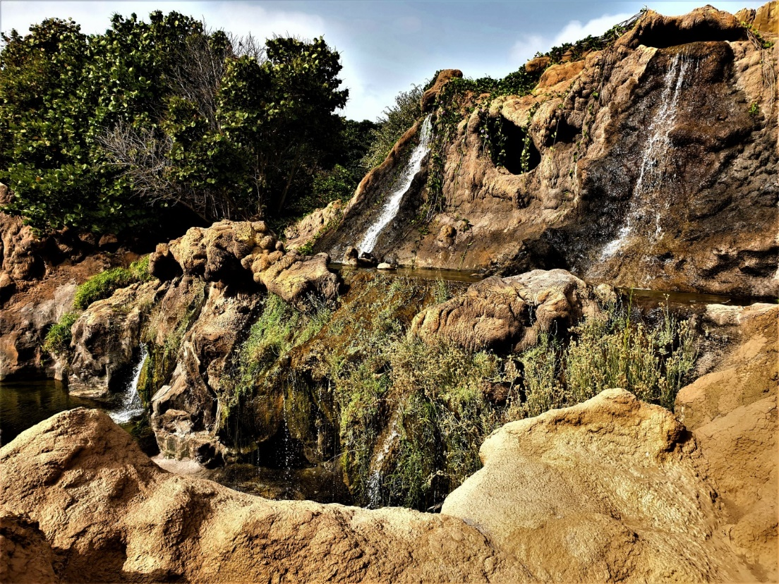 | No less than four waterfalls captured cascading down a collection of cliffs. Shutterspeed choice softening the water just enough. Foreground rocks tend to dominate and draw

 | the eye away from the cascades, but I appreciate that the author may not have been able to get a better angle.
Castle Ruins  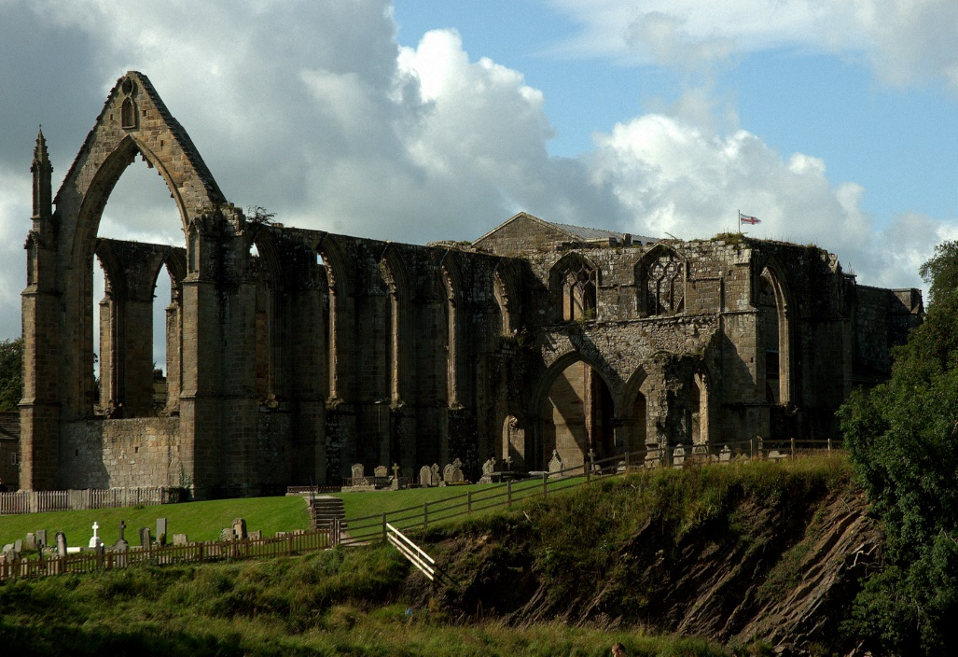 | A contrasty day at this English Heritage site of what appears to be abbey ruins. Foreground cropping would have removed to persons head perhaps up as far as the fence. I like the way the light has captured the gravestones.
Cathedral at night  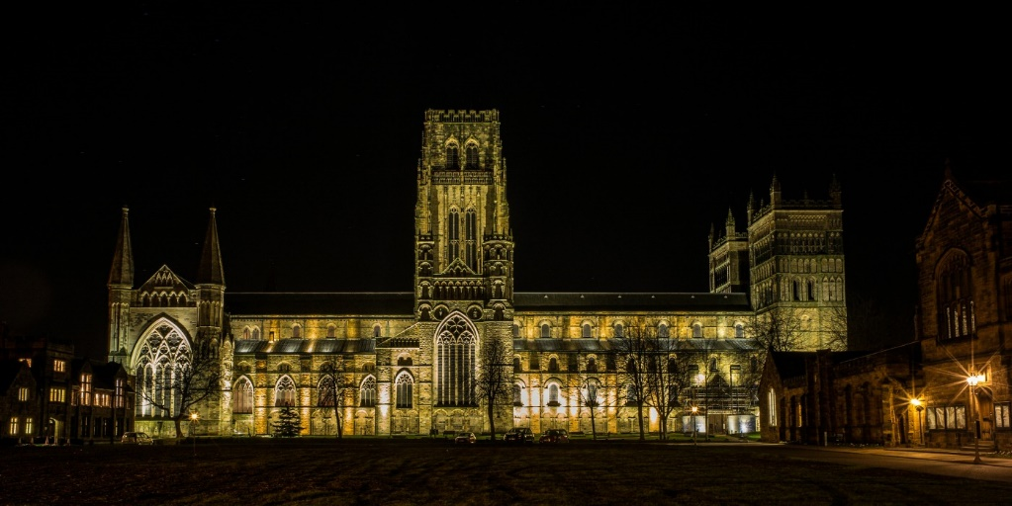 | Good exposure control, view of Durham Cathedral from Palace Green with the University buildings framing it on either side. Sufficient stray light onto the green in the foreground to balance the picture.
Caught in the eye of the tiger  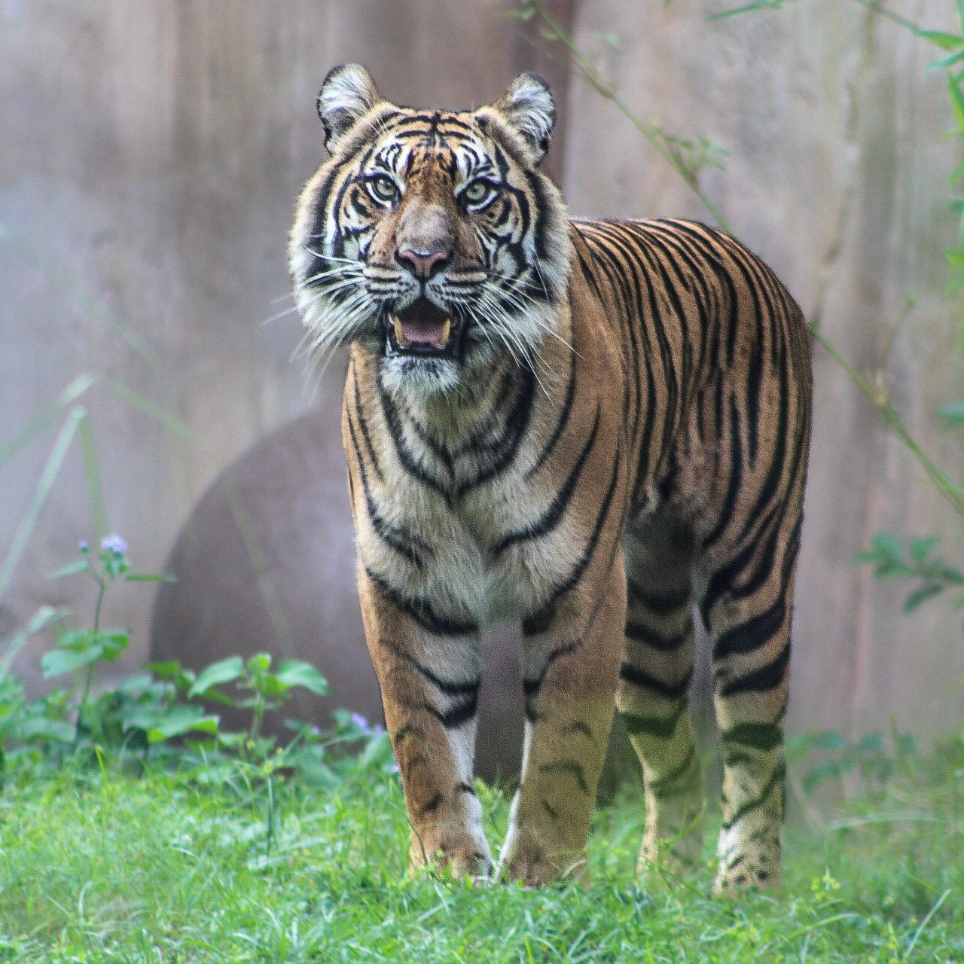 | Powerful image of a tiger, who has posed nicely for the picture! Perhaps taken through glass. I feel that slight darkening of the image would improve the image.
Collecting nectar  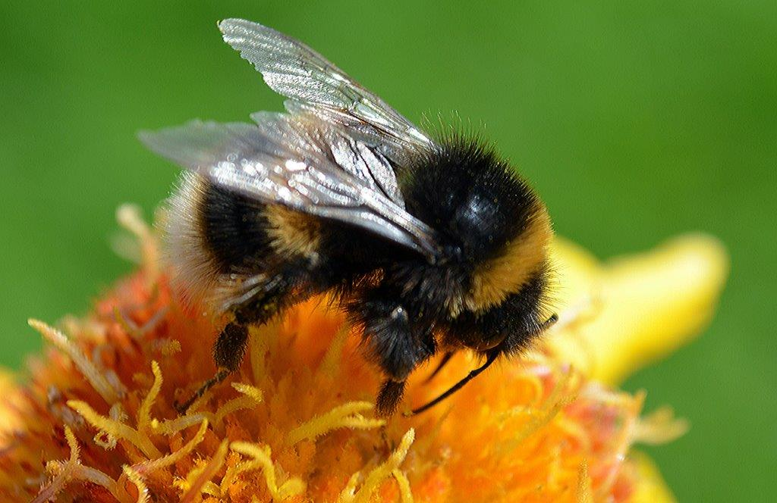 | Another well composed nature image, well positioned, no obtrusive background, demonstrating by camera, what an important part these creatures play in nature, lovely!
Come on baby  light my fire  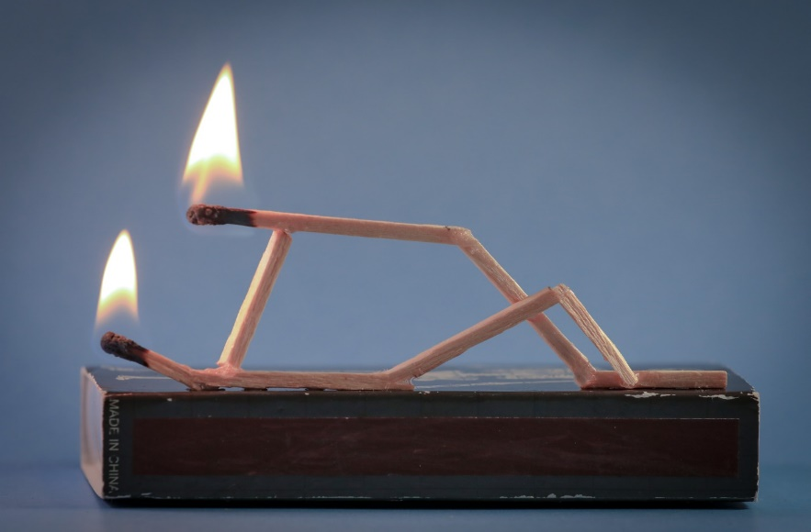 | I love song titles for pictures! This is innovative, funny, well composed and exposed. Perhaps the removal of the made in china text would stop people trying to read it and then concentrate on the ‘passion’ HIGHLY COMMENDED
Durham  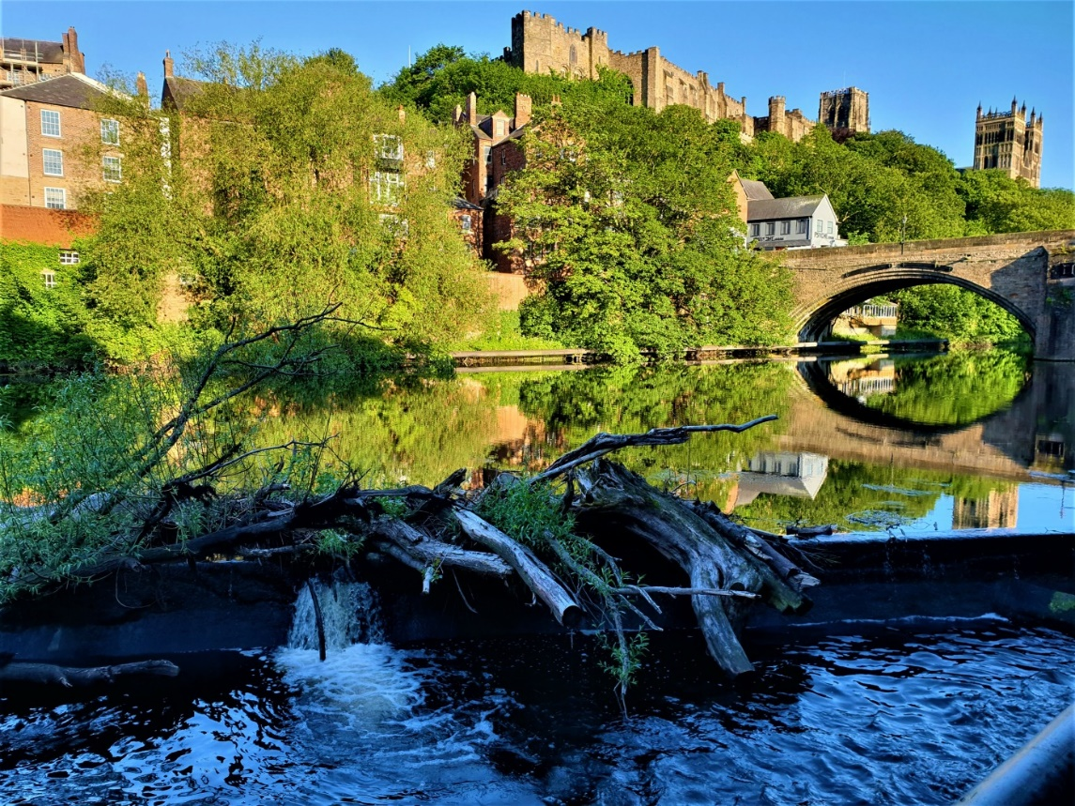 | A popular viewpoint, but this image scores on exposure, shadow detail, reflection, composition. There is composition in the flotsam of trees caught on the weir, again, well exposed. Good
Dutch Bicycle  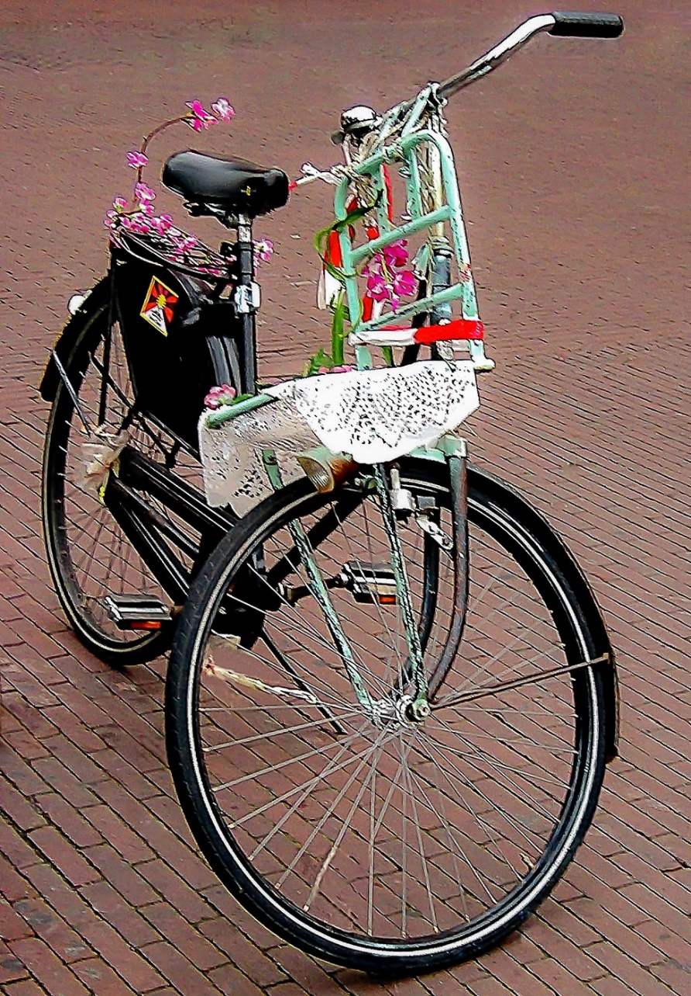 | No brakes, indicating the Dutch style of cycle! Very much a ladies bike with flowers and lace and rear wheel rain guard.  Nicely framed, no intrusions, nice picture.
Emissions  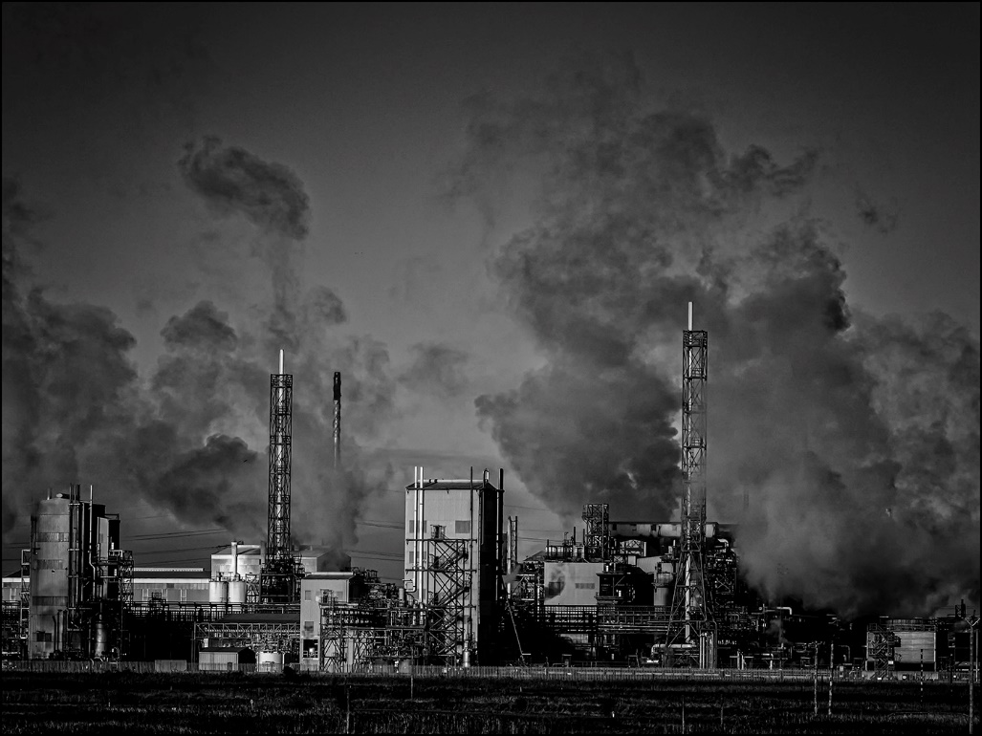 | Strong monochromatic industrial scape, good lighting and sky. Perhaps cropping to the base a little may focus your eyes on the main image content, the grittiness of the industry.
Escape to the countryside  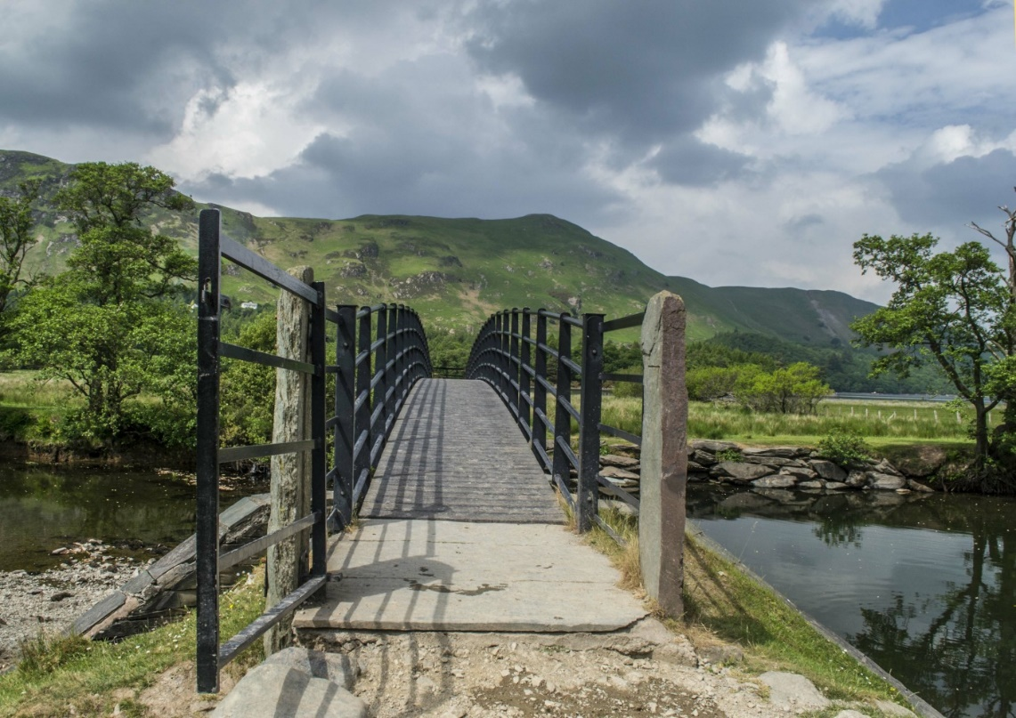 | The footbridge at the top of Derwentwater looking at Catbells mountain. Nice low viewpoint taking your eye on a journey into the landscape. Perhaps a bit more detail could have been achieved in the foreground.
Fawlty walk at Saltburn  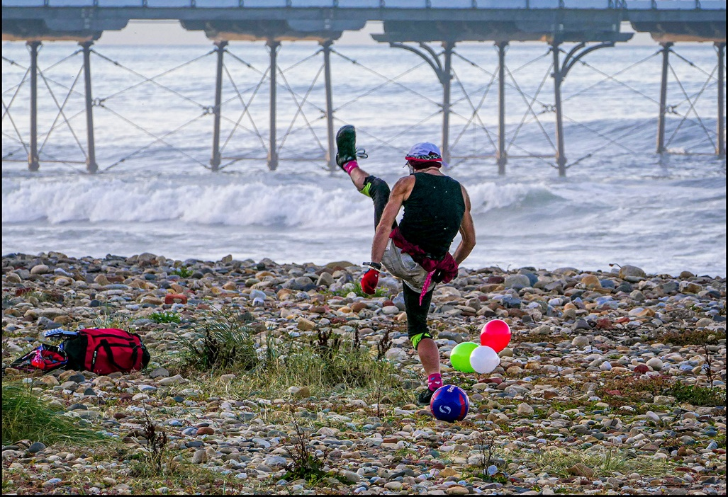 | So much going on in this picture which in itself makes it intriguing! Human interest with exercise, balloons, football, rucksack, all with a background of the pier. Always have your camera with you and you will get fun pictures like this, well exposed as well.

Fishburn miner  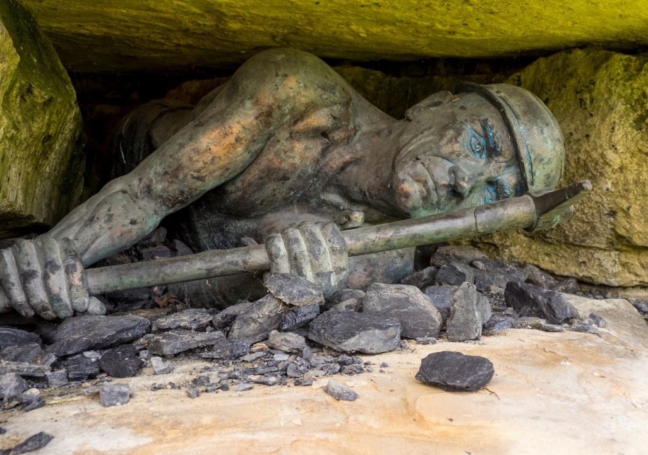 | A blessing that none of today’s youth will have to work in conditions depicted in this sculpture. A mining sculpture with a difference, with impact and well captured here by the author.
Hallstatt Austria  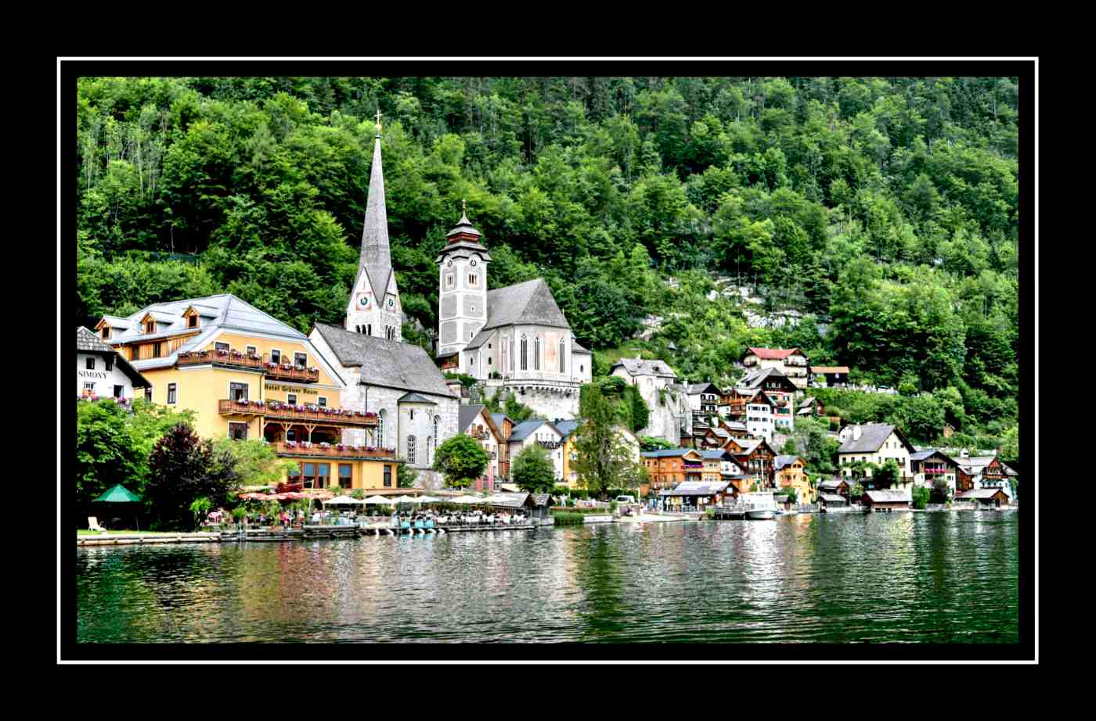 | On the shores of the Hallstatter See, a beautiful place pleasantly captured here. It got its name from salt production, but now a holiday resort. A lot of activity and places to see on the shore, lovely greenery growing up the mountainside above the two churches.
Harmby Falls  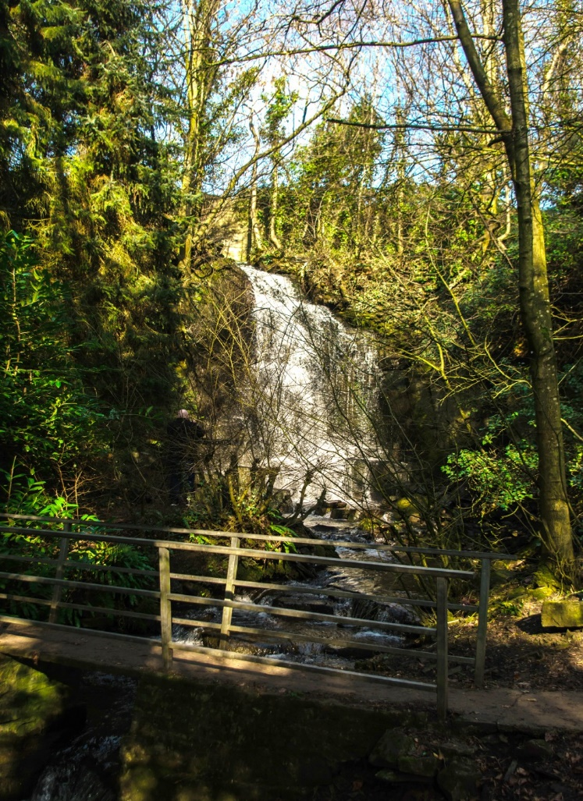 | A hidden spot near Leyburn and well worth a visit with your camera. The author has decided to include the footbridge as a base to the picture which is framed by tall trees to each side; blue skies to the top bring a further interest into the picture. The sunshine has speckled throughout a pleasant image.
Harmby Gorge  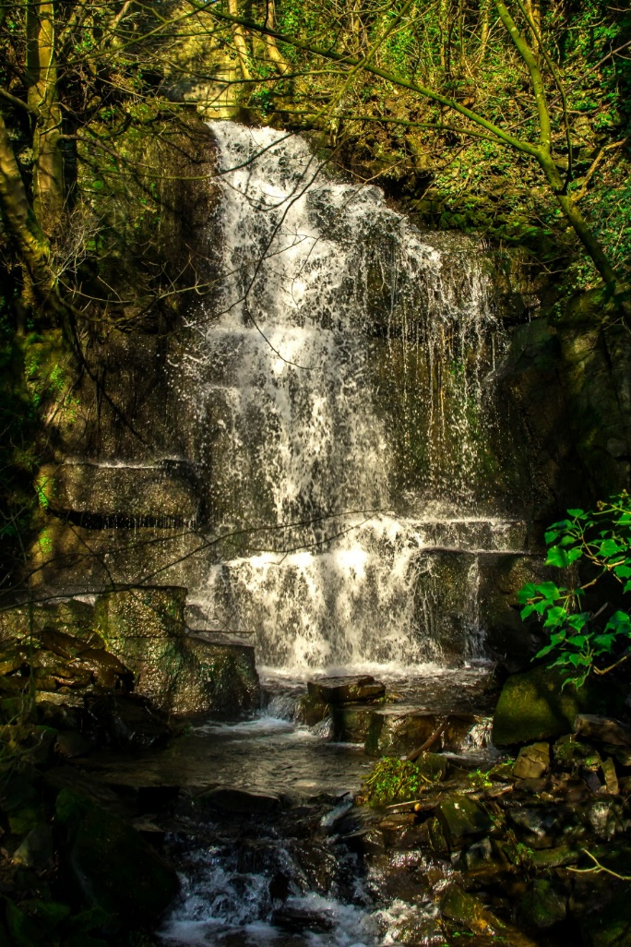 | A well captured waterfall image. A wisely selected shutter speed helps the water dribble down the falls just like icing on the side of a cake. Well balanced in composition with a strong hint of lighter green in the leaves to the right of the picture. Good light filtering throughout the image is complimentary to the overall picture.
Hercule Poirot  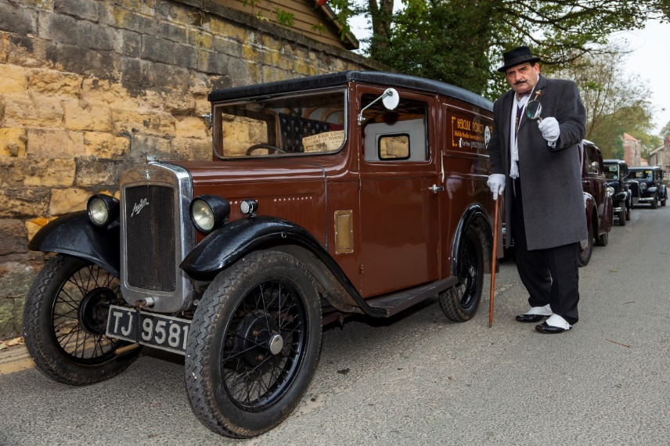 | So often in images taken at re-enactment events are the pictures distracted by the background interference which more than often cannot be avoided. Here the author has seen the opportunity in seeing the image, and possibly identified the contribution the background plays in telling the picture. Clearly Hercules plays a big part in an enjoyable image well captured.
Hogwart Express  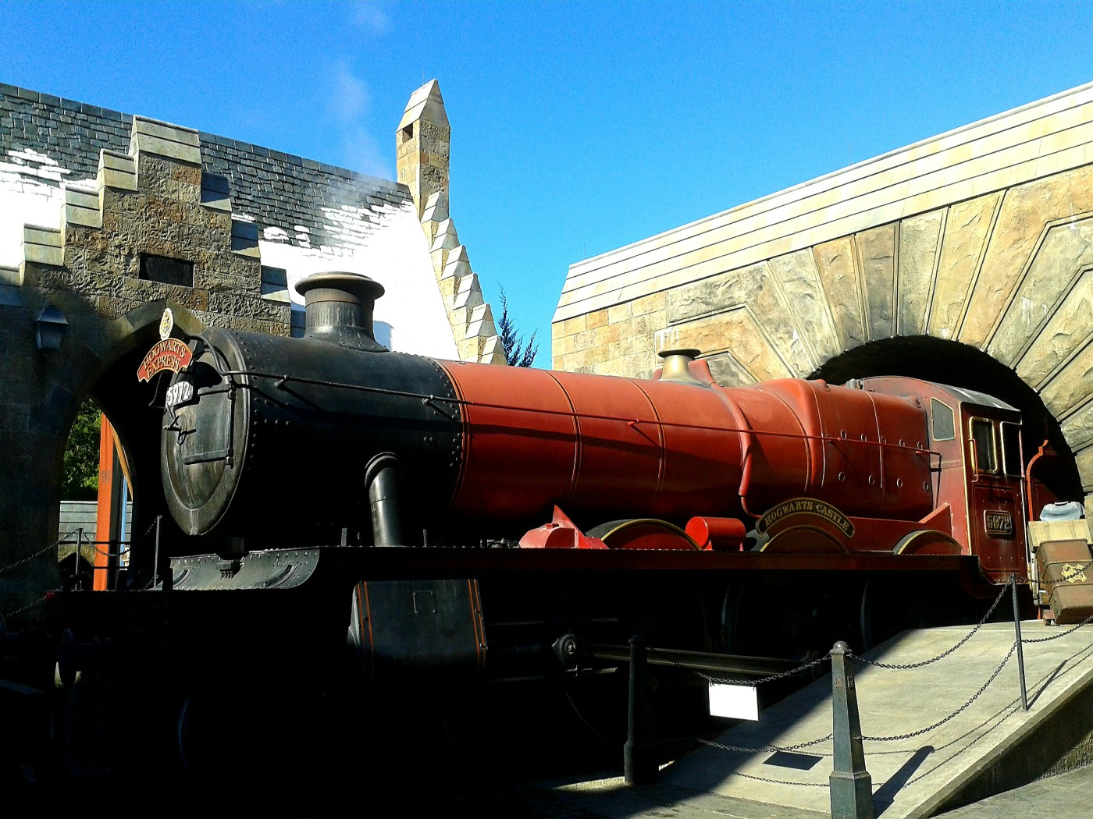 | Nicely composed image of the train that’s has caused so much enjoyment for both children and adults. Taken on a contrasty day, which has provided challenges for the author in that key parts of the composition are in shadow, and aspects of the roof, which appears to be snow, burnt out a little. Perhaps bracketing of exposure could help if the author is confronted with this type of contrast in the future.
Holidays in the past  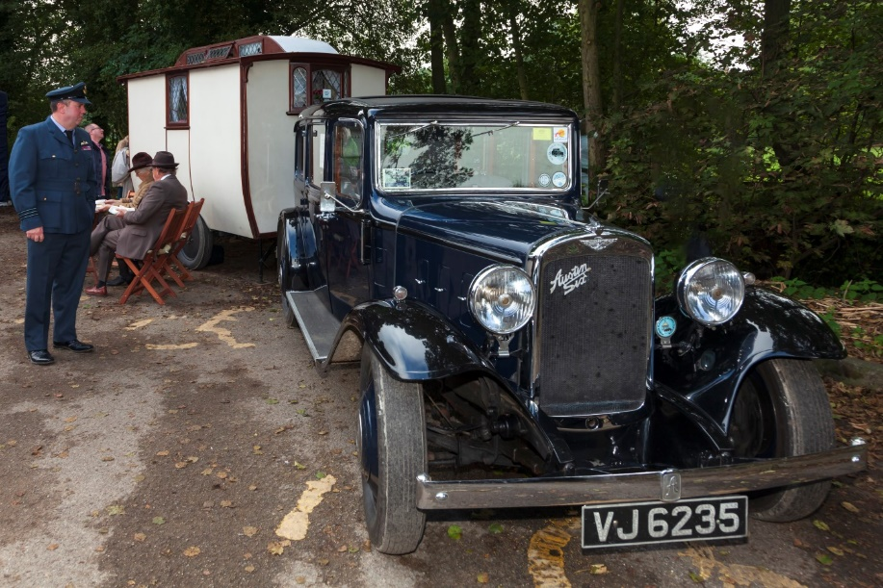 | A caravan and tow car from the past, long before electric hook ups and solar panels were around like today to make caravan holidays such fun. I like the composition, showing the power and design of the tow car taking your eyes back to the old caravan, human interest as well creating an

 | interesting image, good shadow detail in the car.
In full flow  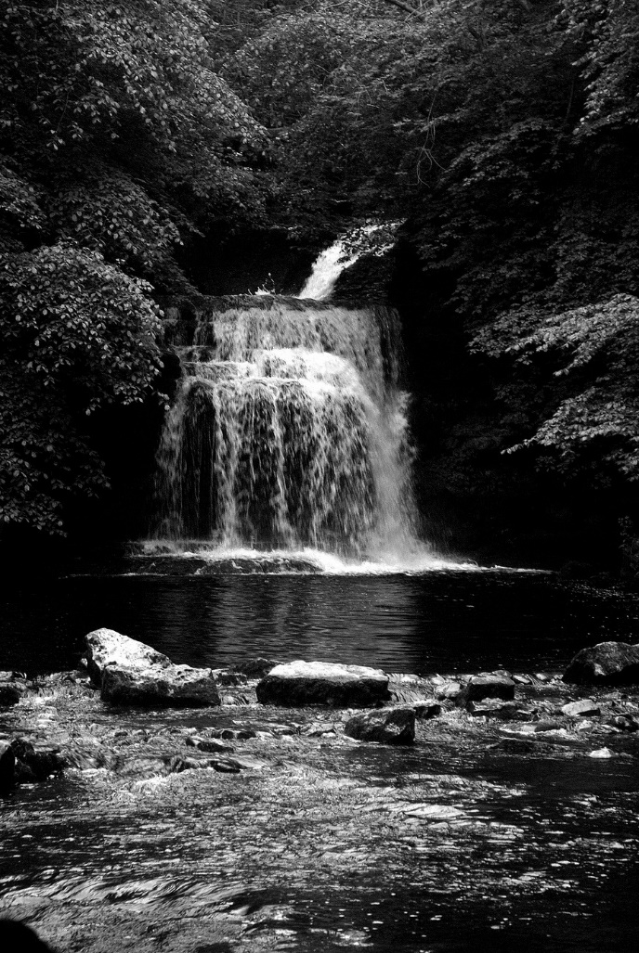 | A monochromatic treatment of a lively and gushing waterfall. Quite a dark image, especially in foreground, but the author has seen the benefit of the rocks in the foreground which contribute a lot to the balance and exposure of the image. Trees either side create a pleasant curtain effect to a well composed image.
It won’t start  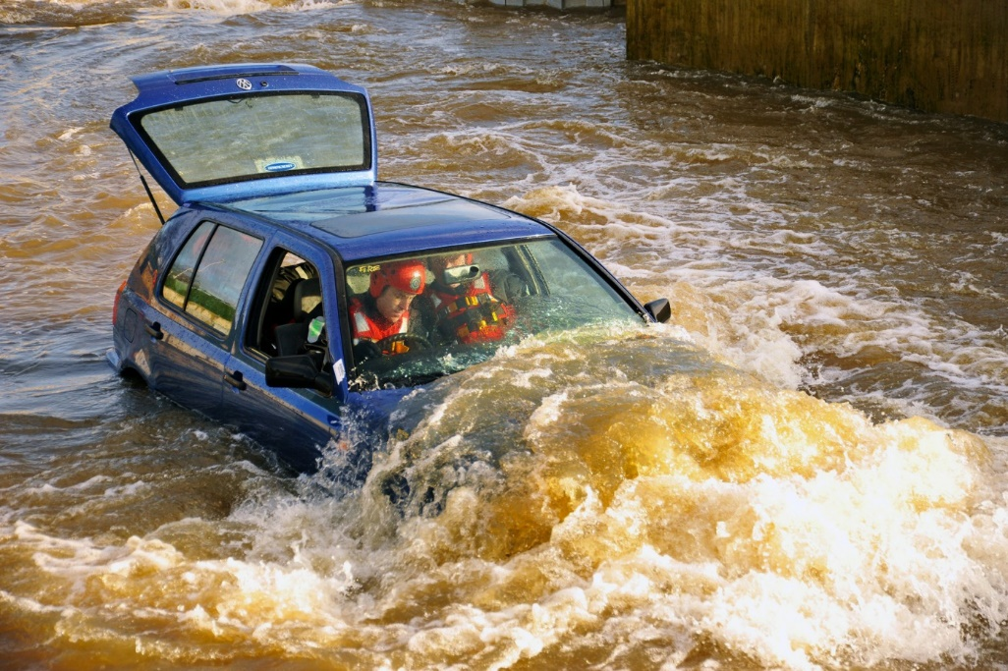 | Always have your camera with you! Well captured event showing the demise of a VW. Perhaps a Fire Service exercise as the word Fire is written on the windscreen as if it’s a ‘prop’ car? Anyway let’s hope the two occupants get out safely. Their faces, ably recorded in detail by the author certainly look as if they are in control.
Kelvingrove Art Gallery  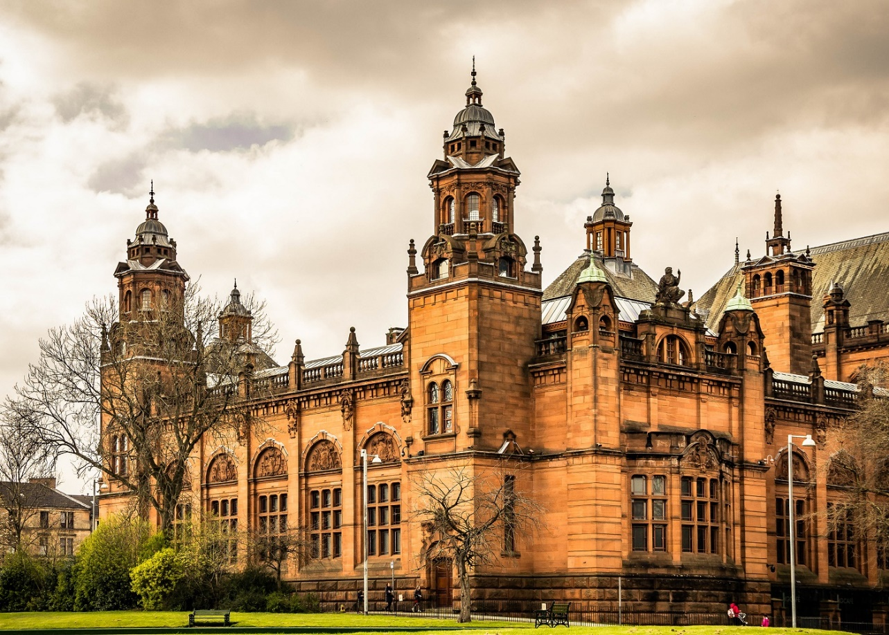 | A fine art gallery in Glasgow. When taking a detailed architectural landscape it is important to get everything sharp and in perspective. The author has achieved this, with sharpness throughout, good detail in the exposure, enough human interest not to distract. Nice
Kingfisher  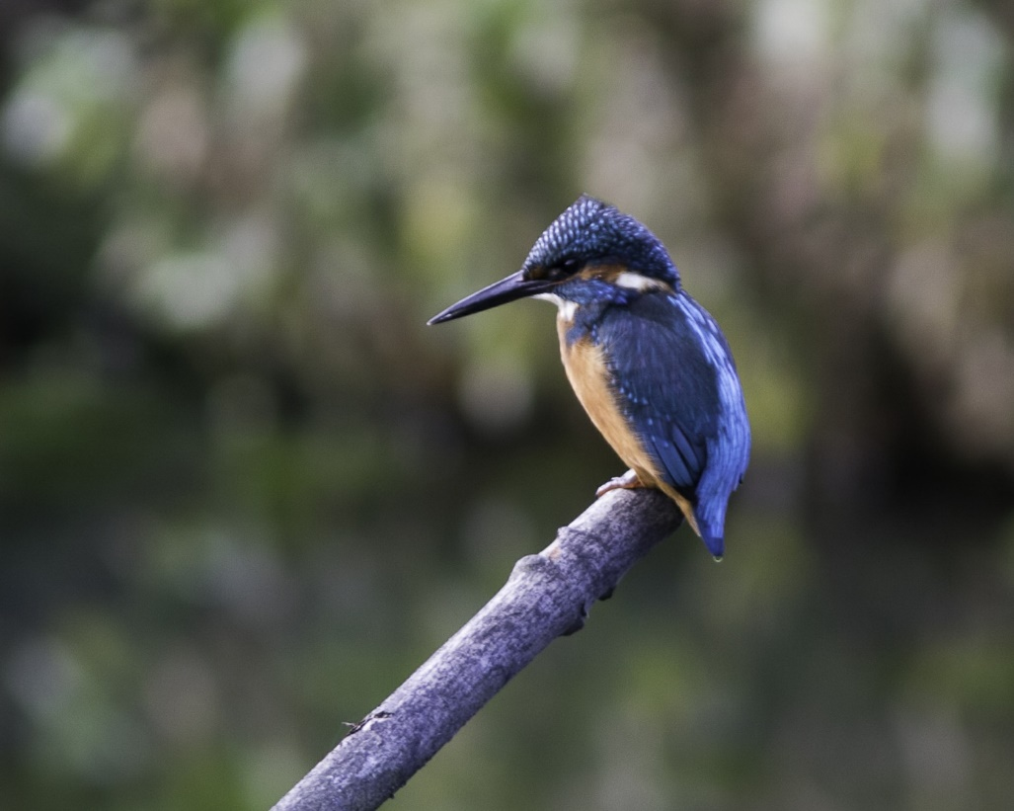 | Good composition with a strong diagonal shape to the branch which takes you nicely to the key point of the image. Background is unobtrusive, but provides colour and shape which contributes sufficiently to the image. Slight camera shake evident.
Late night in Cologne  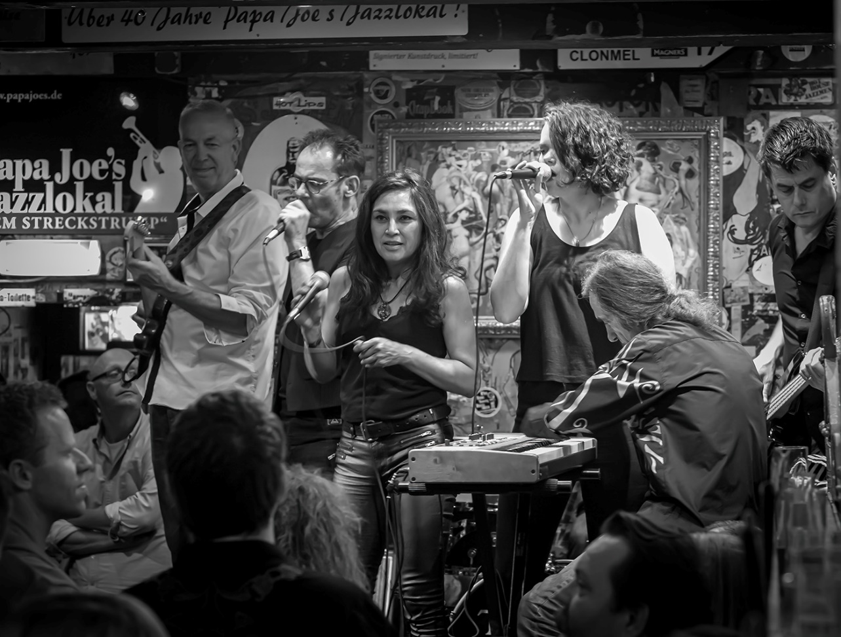 | So much going on in this picture, all of which contributes to an interesting people gathering in Cologne. Author hasn’t just taken a snapshot, but has had time and thought to create an interesting composition and good exposure. The mono treatment works well. Good shadow detail and tonal range. If I was to be picky, I would remove the text strapline to the top of the picture, or, if possible, include all of it.  HIGHLY COMMENDED
Let’s be friends  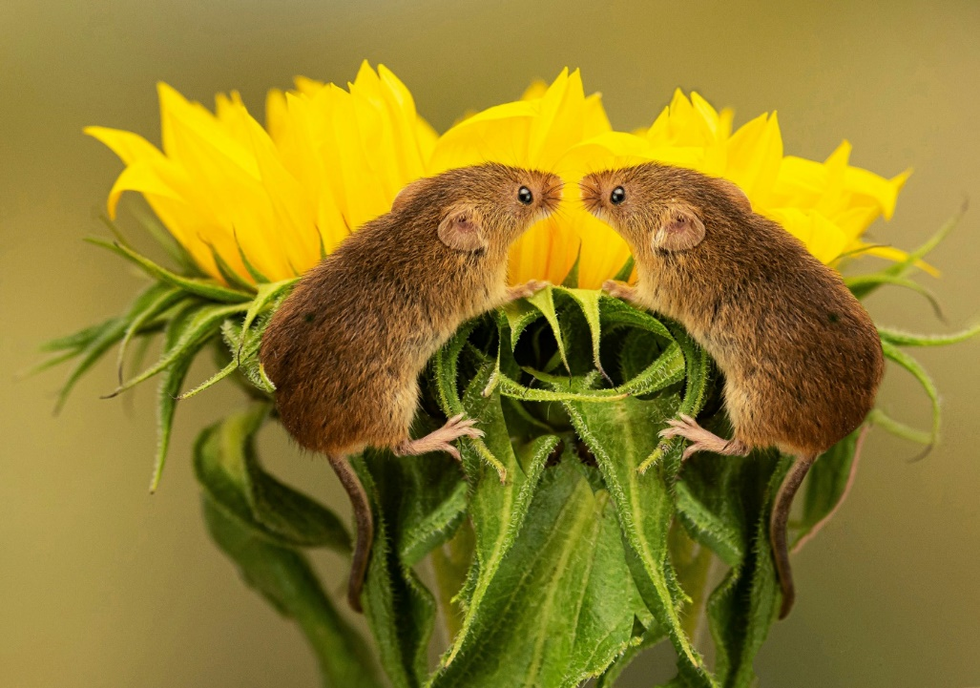 | A well exposed and composed image of two mice on a plant. Good colour choice of plant and background, plenty of detail in mice. An image which makes you smile.
Lock down  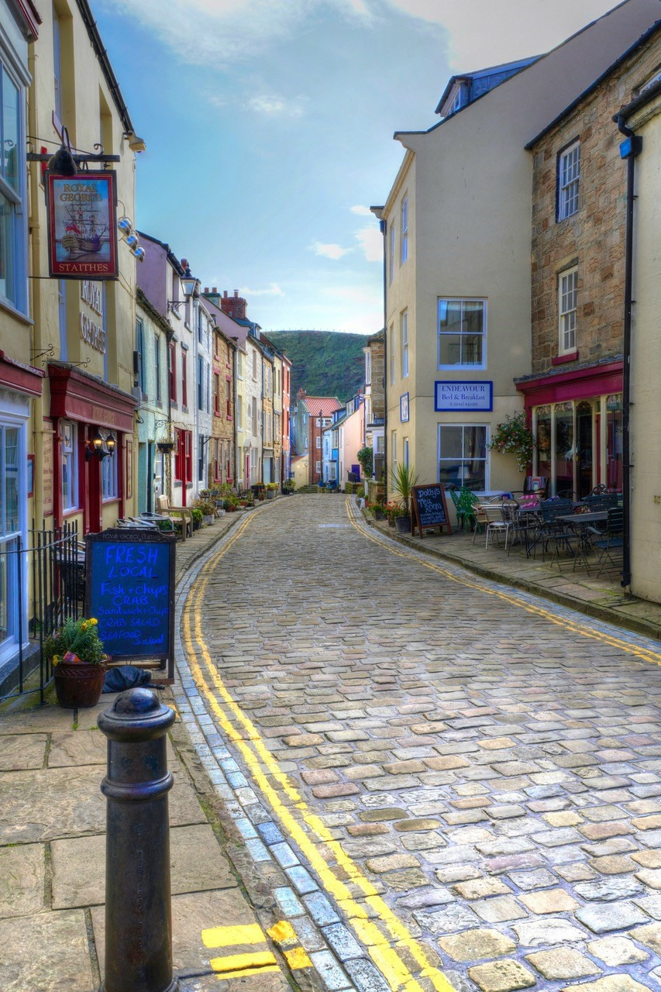 | Lock down in Staithes. I Like the upright format for this streetscape image, and the post production introducing a ‘painted’ effect to the buildings enhancing their colours and thereby increasing the power and desirability of the image. Good composition, taking you along the people free street.  If I was looking for shortfalls, perhaps the metal post in the

 | foreground could have included the base area.
Lunchtime snack  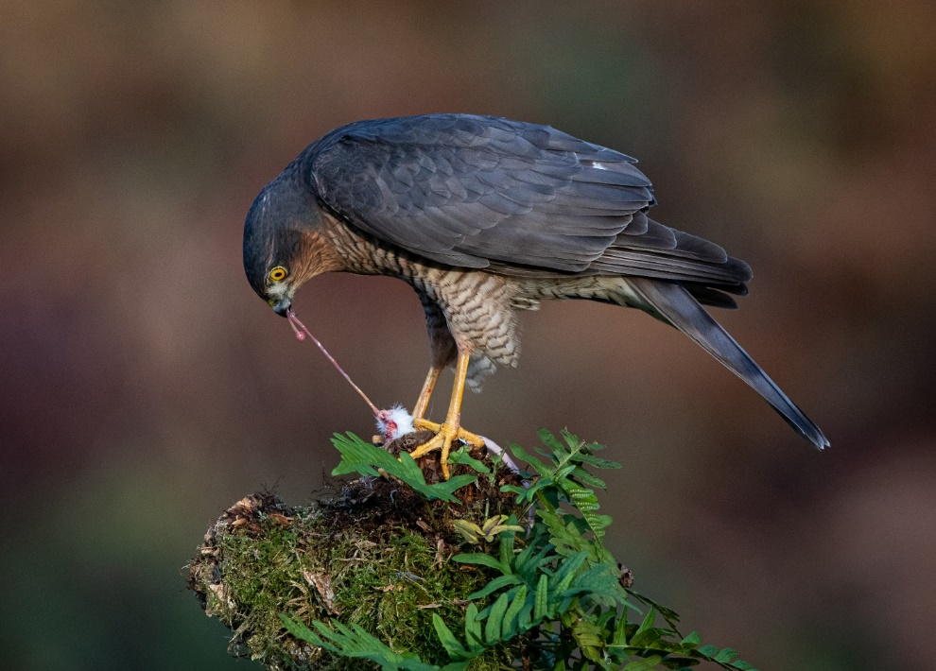 | Perhaps the author has placed the ‘snack’ on the branch awaiting the arrival of the hawk, good move if they have, if it’s a genuine lucky shot then well done! Regardless the execution is first class, diffused background, but not a plain canvas, good differential focussing used, just enough greenery on the stump and capturing the bird pulling the sinew just completes what is a very good composition.
Male Sparrow hawk  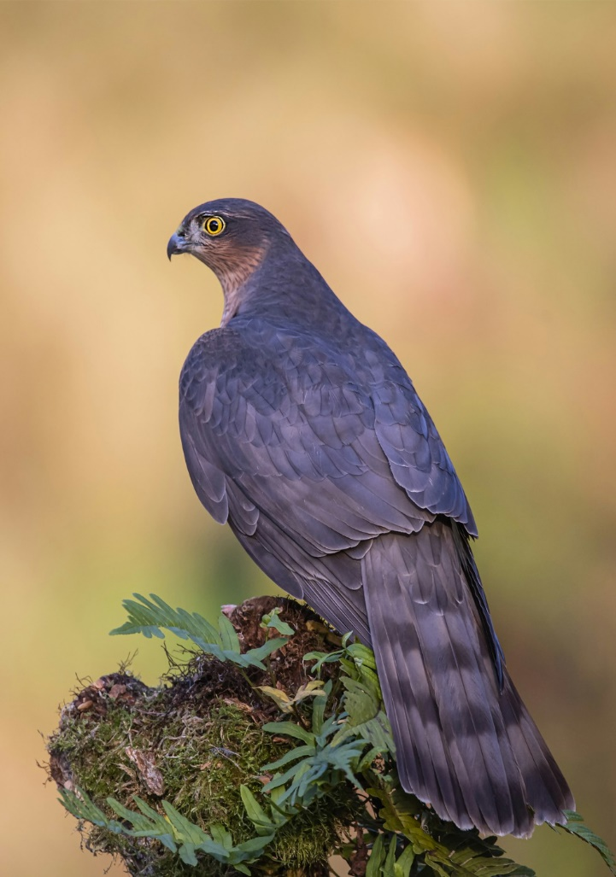 | Perched majestically on this wood stump, its wings relaxed in a resting mode, a sparrowhawk exuding confidence in its arena. Photographically well competent in this field, exposure, composition, sharpness all of a high standard.
Mallard  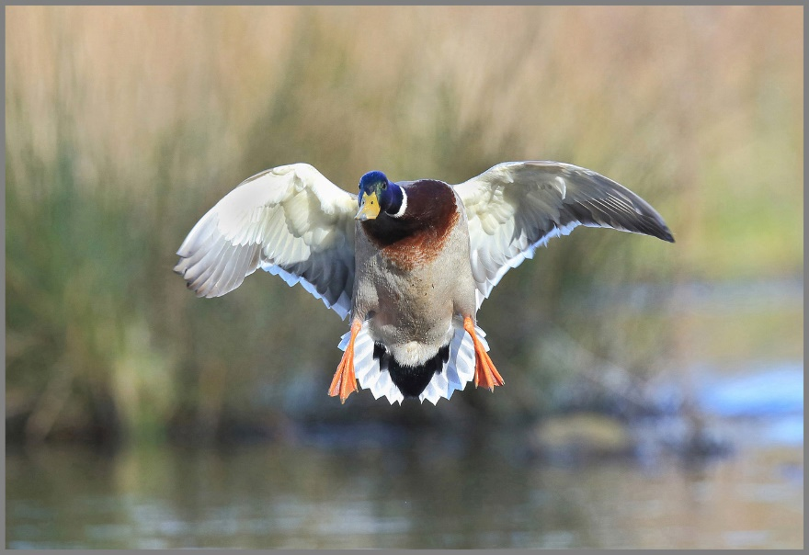 | Caught in flight, facing the right direction, full glory of its plumes and those powerful paddle feet. No background intrusions, depth of field control and exposure. Well done.
Monserrat Monastery  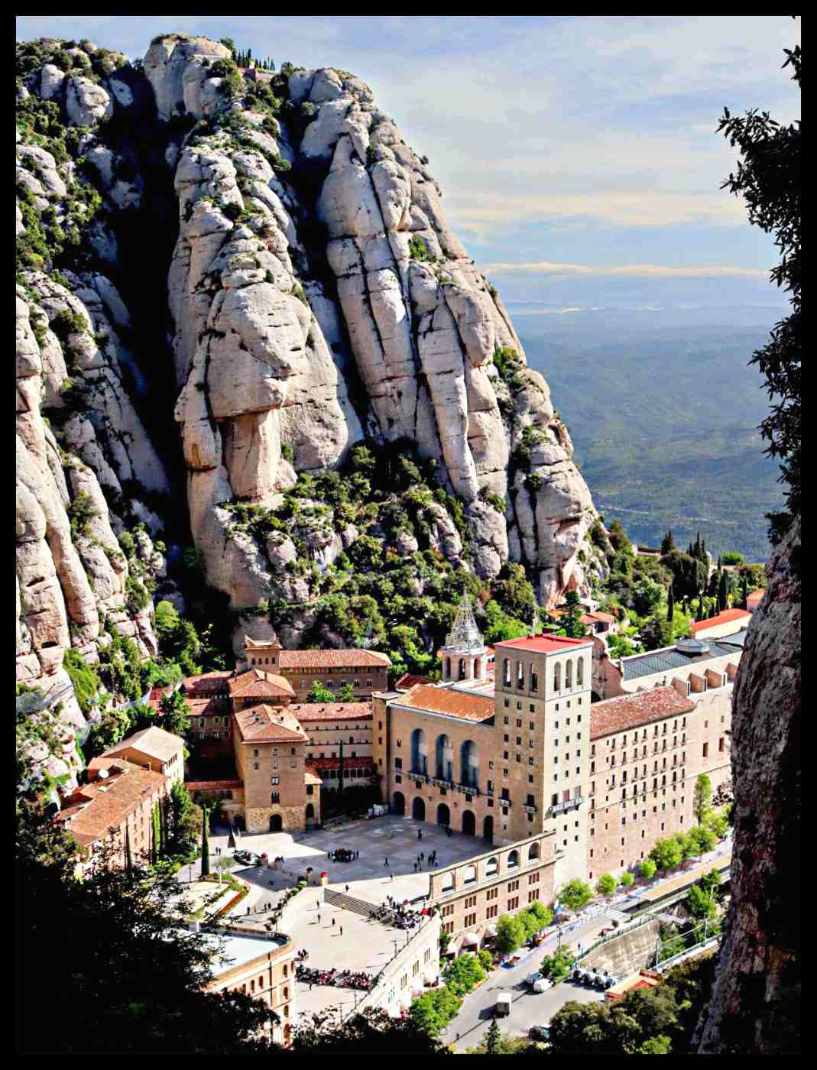 | An elevated view of this famous Catalonian Monastery which is such a popular visitor attraction. Still the home to monks after centuries of habitation. The towering rocks behind the buildings give a sense of scale to the image, the silhouetted trees to the bottom left foreground and right side contributing towards the framing of the image. The queuing crowds outside the Monastery telling us how popular the place is. There is scope to darken the image, especially the paved area in front of the monastery.
Mouthful  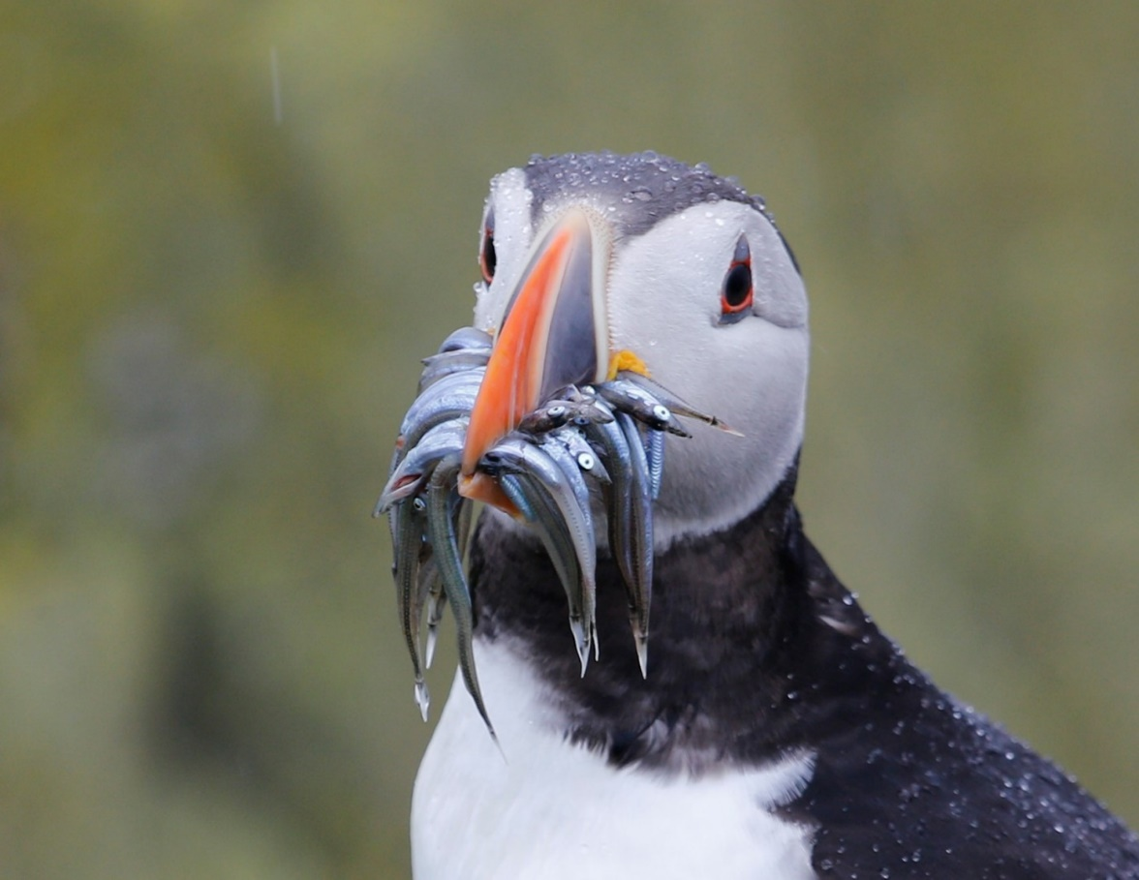 | A hungry puffin, or provider of a big family!, whatever, it is well captured here by the author. Sharp, look at the water droplets on the bird’s head who has kindly posed for the photographer. Well positioned in frame, however, I feel more detail could be achieved in the birds white breast.
Nashville Union Station Foyer  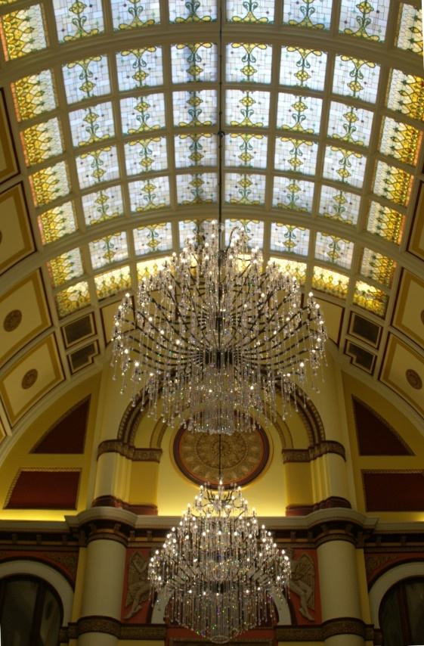 | Now a hotel I understand, but opened as a railway station in 1900, hence the grand designs of the time captured here by the author. Large chandeliers well positioned in the frame under a beautiful curved roof with stained glass allowing plenty of daylight through the roof. Well composed and exposed.
National Union Station Hotel  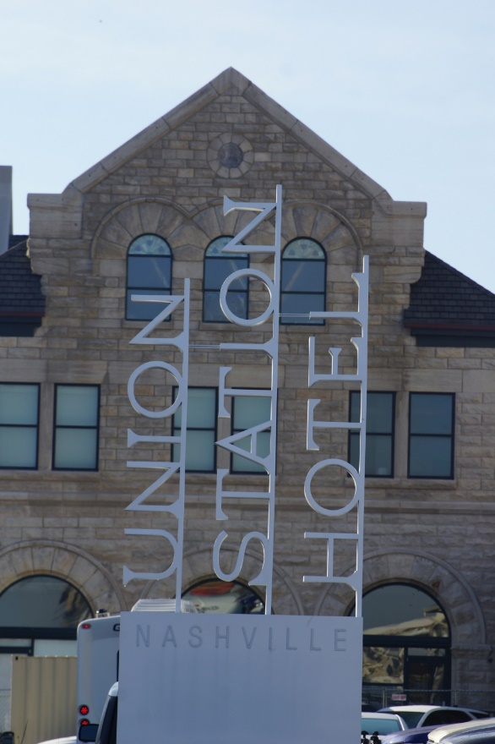 | The modern signage fronting this 1900’s building blends in well. I admire the used of steel in its construction, and the design which I initially interpret as trains arriving at the station. A post production crop of the vehicles in the foreground could have helped this picture.

No swimming  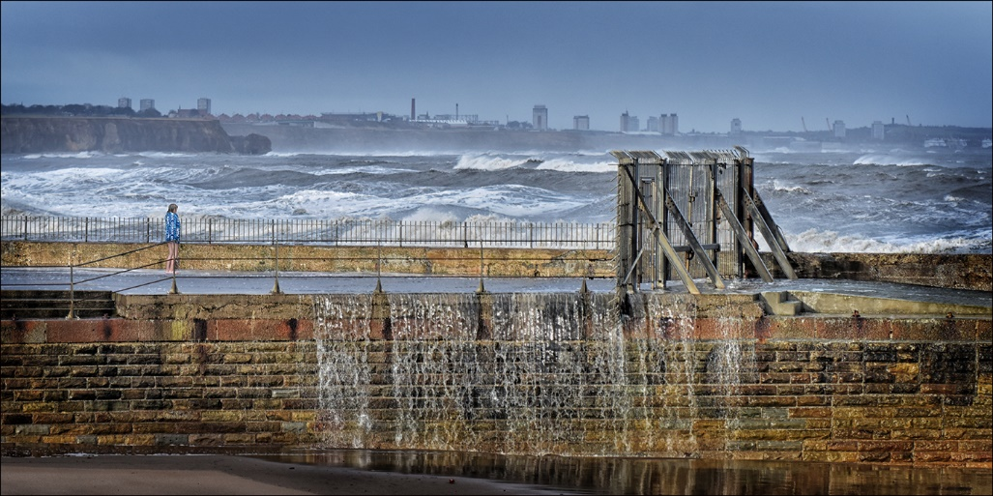 | Definitely no swimming today! The physical power of the locked pier gates contrasting against the diminutive person wrapped in a towel give a clear message and indeed power to this picture. The figure is so important to the message, the sea running off the pier in the foreground and the waves getting ready for the next splash. I like the background recession of tones through the waves and the background frieze completes an eye catching image.
On the wing  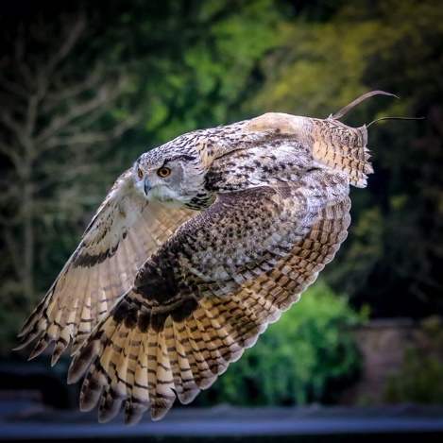 | A well captured picture of this raptor which seems to be giving a display as seen by the ankle straps trailing behind it. Lovely light in the right place, I like the square format. Good control of shutter speed and exposure.
Poser  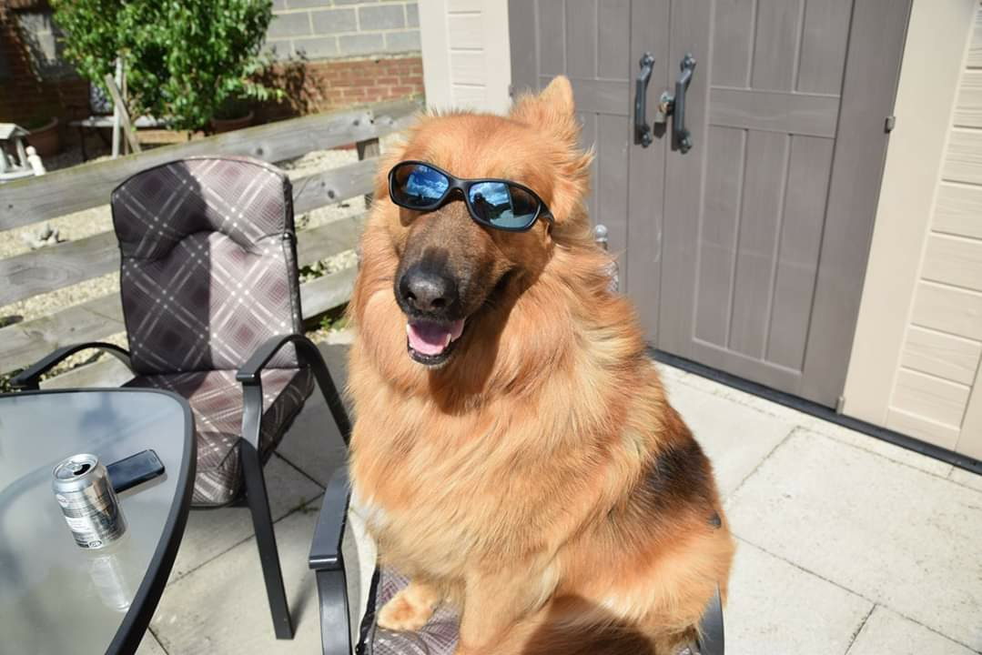 | Well captured and happy image of this dog who has just come off the phone and put their drink down to not just pose, but smile for the camera! Such control, there are many children who won’t even do that! Well captured and controlled.
Raspberry sky  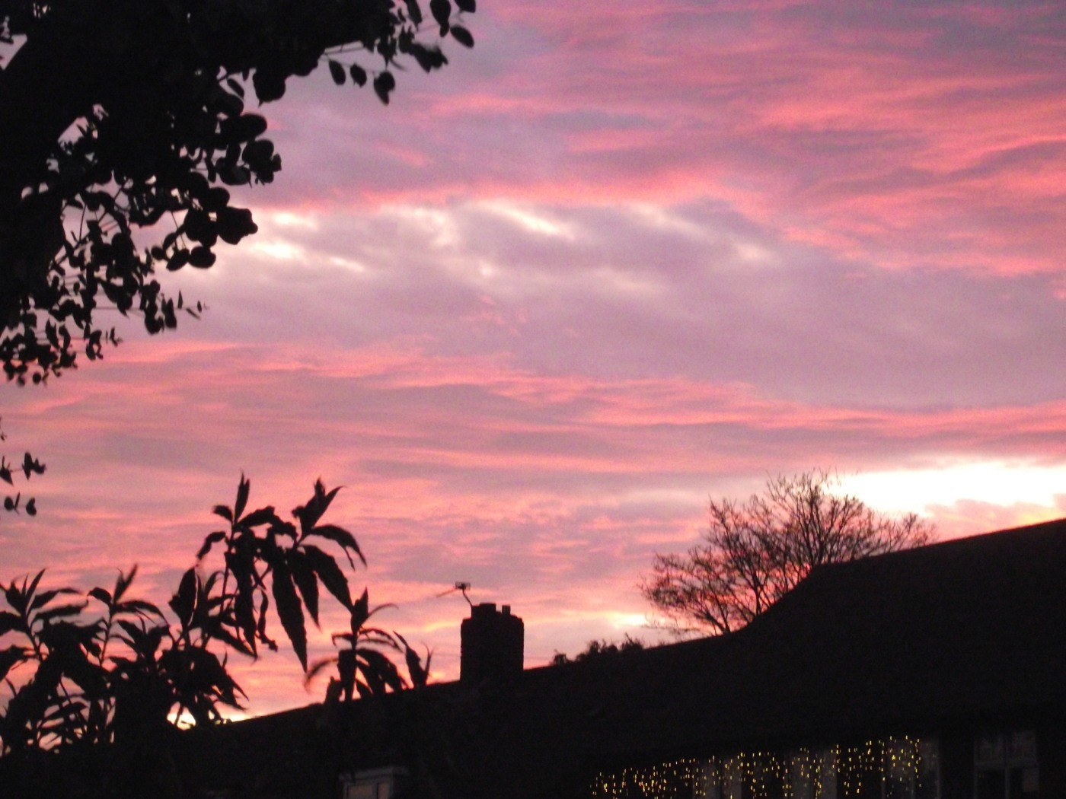 | Sunsets always fascinate me, they are soothing and makes you forget about what is happening in the world! In this image the author has seen an opportunity and grasped it, sharing with us all a lovely raspberry sky. Post production could have enhanced the overall image by cutting an inch or so off the bottom.
Raspberry  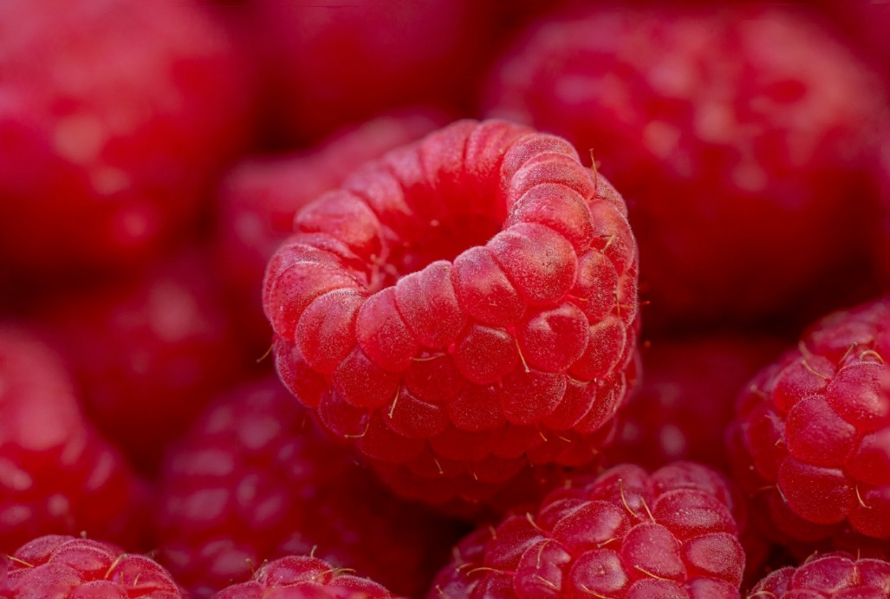 | Such a lovely fruit to grow in your garden if you can keep the bugs off! This is about shape, colour and nature all blended together to make a lovely image. Good choice of aperture highlights the central raspberry with the surrounding crop supporting the image with colour and shape. HIGHLY  COMMENDED
Ravaged by time  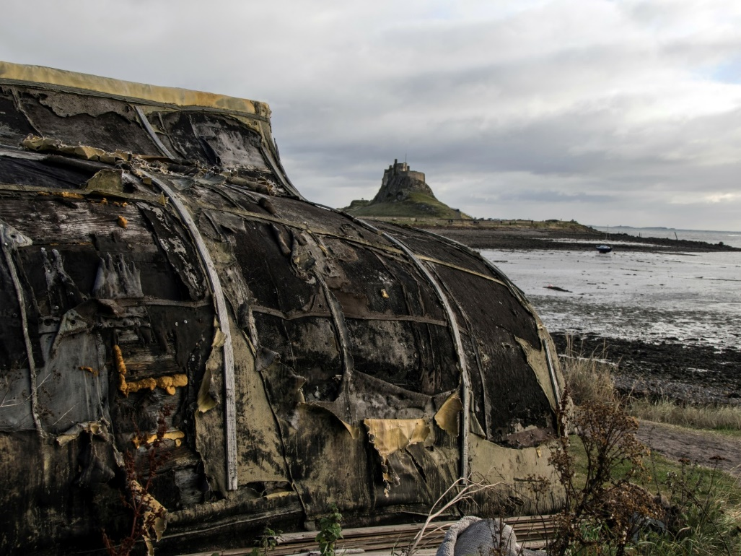 | The upturned fishermen’s huts on Lindisfarne with the castle in the background. Taken on a gritty sort of day with the tide out. This place probably more photogenic off season. The strong features of the boat hull, torn by weather and time are recorded well here, it is the central part of the image and holds its own with the castle background bringing in the background interest.
Road to hell  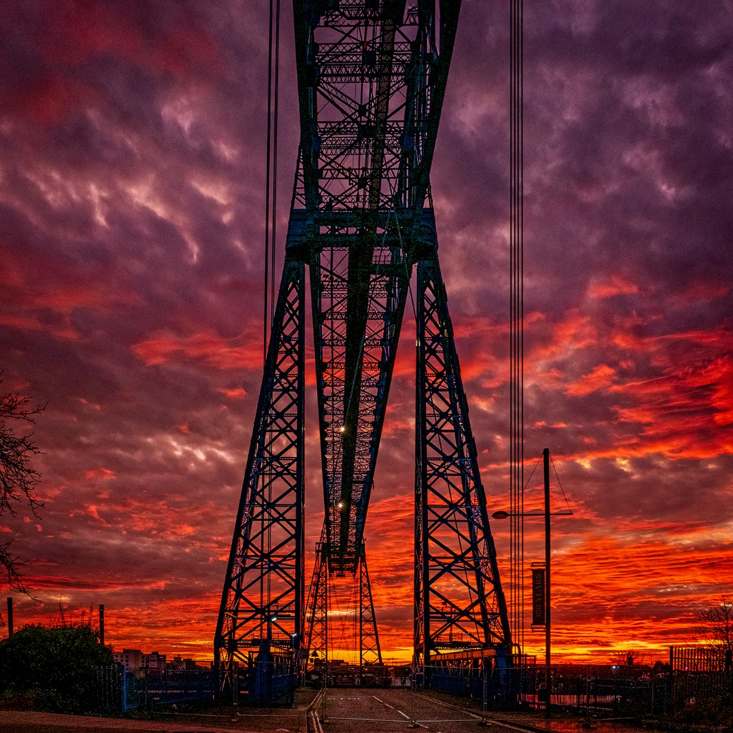 | Wonderful sky, filling the picture where it matters. A fine combination of steel gives structure, strength and interest as an industrial silhouette. Well exposed and composed, super sharp. I find the branches on the left of the image introduce

a little imbalance and could be removed. HIGHLY
COMMENDED
Sasha n bubbles | A bold venture taking a jumping dog trying to catch bubbles in the hope that everything will be in focus and sharp! Well done for trying it, the autofocus has picked up one bubble but everything else has just missed out. Never mind, it’s a fun image with a very happy pet.
Sasha  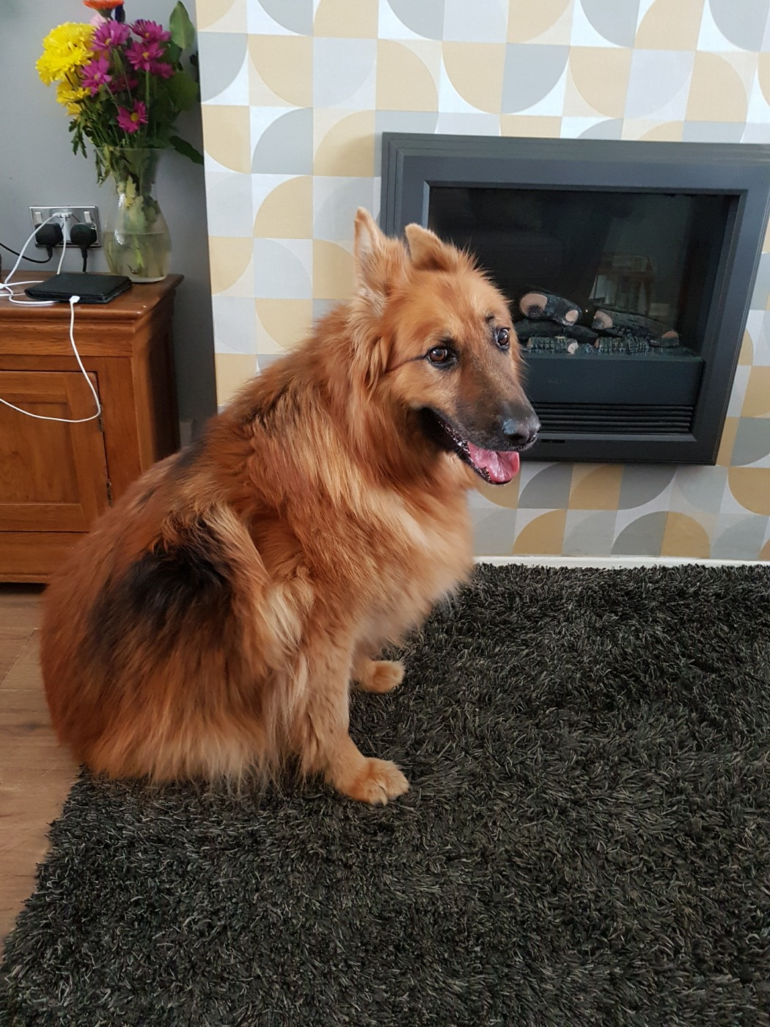 | Here’s Sasha on her best behaviour, posing for the camera in a nice sharp and well exposed image in front of the fireplace. Clearly a photogenic dog, you must keep photographing her! Try to choose your backgrounds to avoid stray items taking the viewers’ attention away from the main subject. Good try.
Shining like a National Guitar  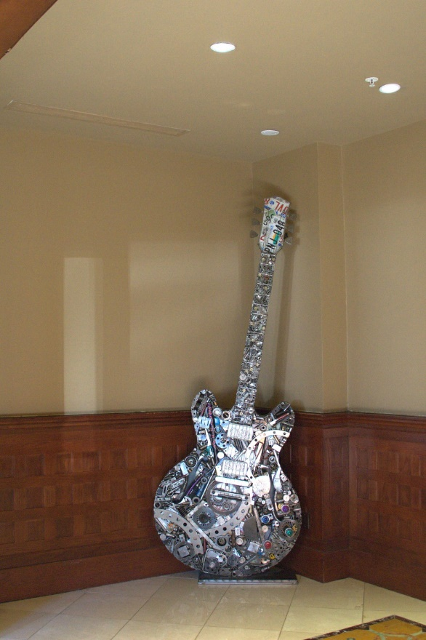 | It certainly is! An interesting instrument resting on a plinth would cause any photographer to get their camera out and record it. The picture would improve I think with a crop all around as there are bits around the base which don’t contribute to the image. An interesting piece of art.
Sky dancer  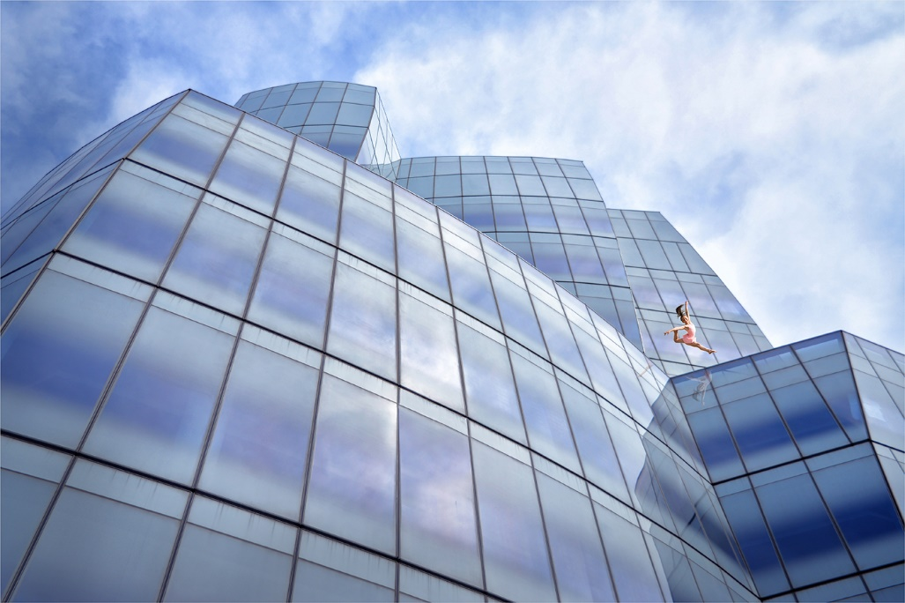 | Impactive image, shape, well exposed throughout. Nothing in the picture which doesn’t contribute to the overall image. The shapes are well seen. The introduction of the dancer is very good, position, and pose, reflections of the dancer in the glass. I wonder if zooming in on the dancer a little would  enhance the image. Good photography. HIGHLY  COMMENDED
Soft landing  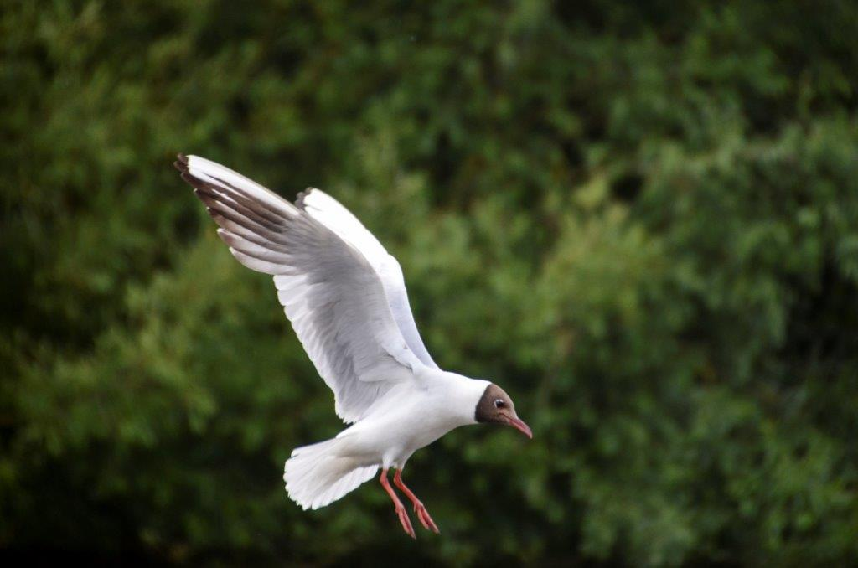 | Well captured gull about to land. Good aperture choice diffusing the background sufficiently. Perhaps too much space to the top of the picture which takes your eye away from the main image.
Sparrowhawk  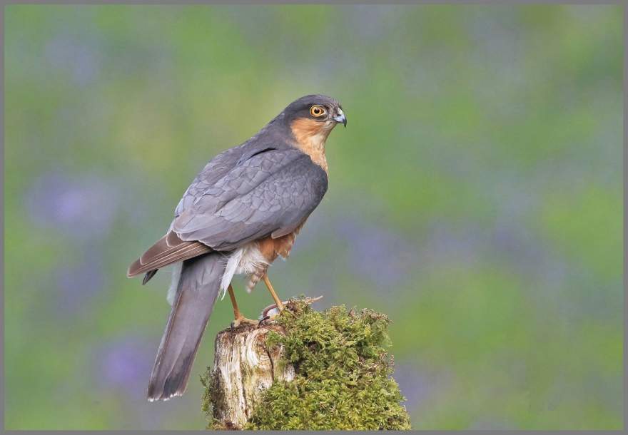 | With a mouse at its feet on this perch, again good aperture choice losing the background sufficiently so that it plays its part as a supporting background. Capturing the bird looking at the camera is a skill which has clearly paid off here.
Spring has arrived  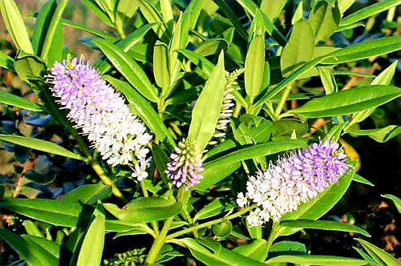 | And hasn’t it just! This floral and greenery collection makes a nice pattern in this picture. Composition and shapes are good. Taken on a bright day means that key parts are a little burnt out, try adjusting in post process, or stop down a stop on your exposure at the taken stage should enhance your results.
Staithes at | A well captured image, a serene time of day as the village is

Daybreak  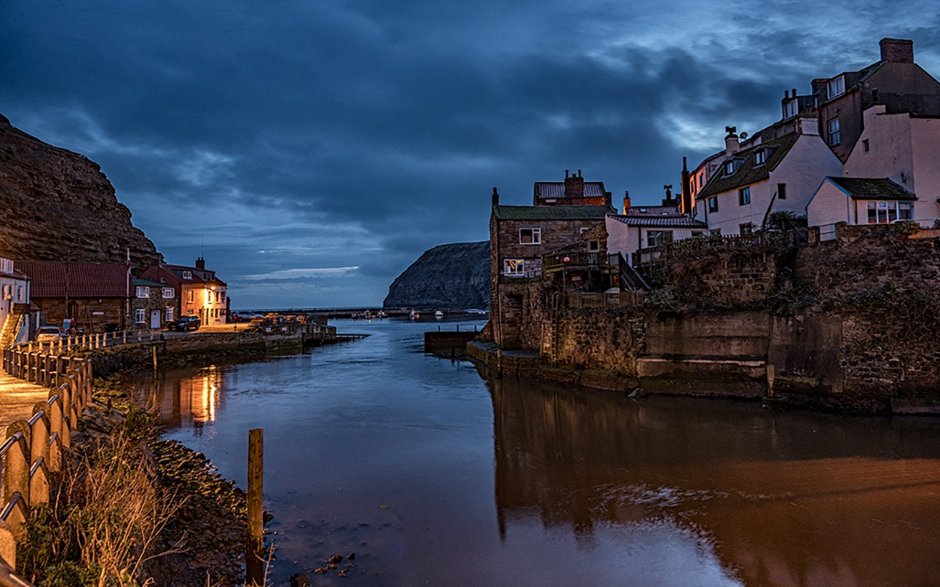 | waking up. Good light introduced in necessary places. Good lead in on the left with the illuminated fence taking you into the picture to the building at the end. The illumination of that building is a powerful part of the picture. Your eyes then travel through the sky and back through the cluster of buildings. Well composed and exposed. Good shadow detail.  HIGHLY COMMENDED
Starlings  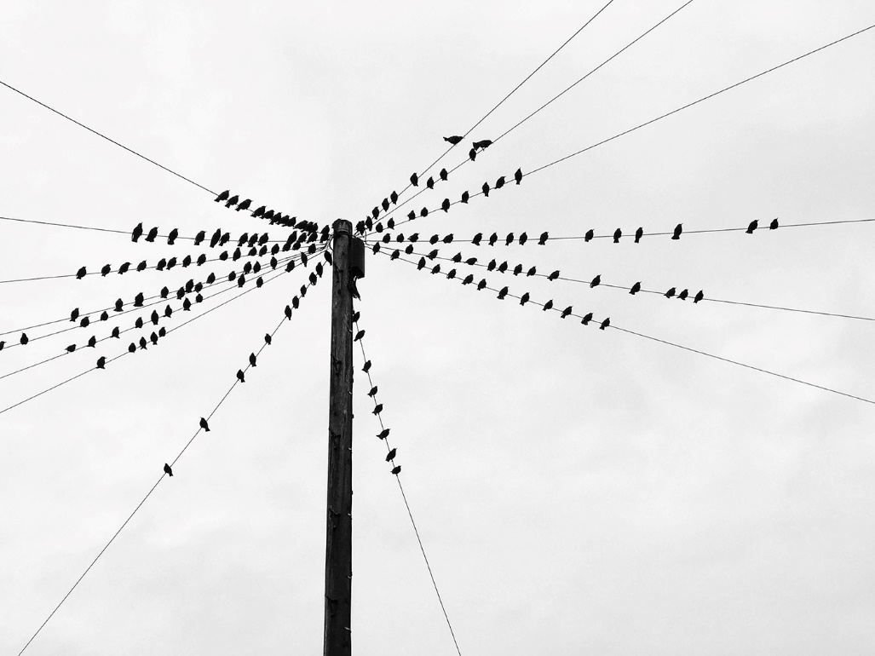 | A well spotted pattern picture of starlings resting on telephone wires. Each wire has a cluster of birds, although some wires are more popular than others! The stark mono treatment works well with nothing to distract the patterns caused by the wires and the attractive bird collection. I wonder what they are saying to each other?
Sunset over the lake  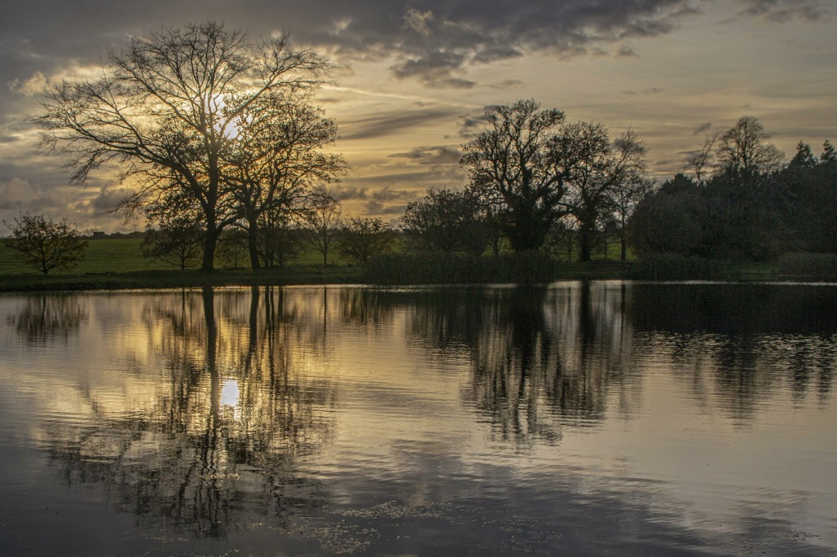 | Lovely light and reflections captured on this sunset over the lake image. The dropping sun behind the trees and its reflections are particularly subtle. We seem to have lost a lot of shadow detail to the right of the picture.
Tasty treat  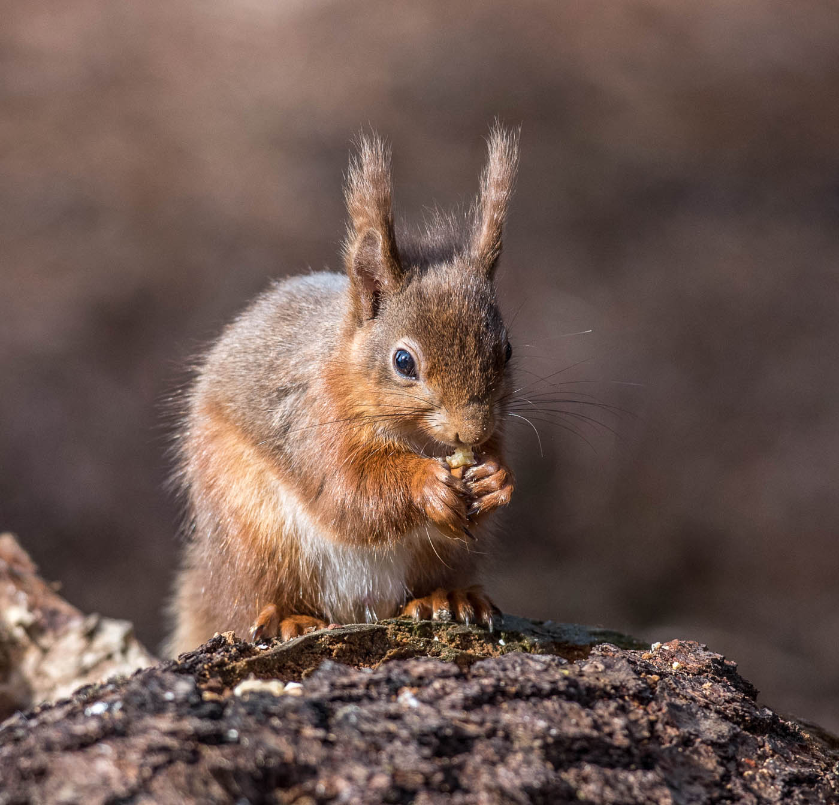 | Lovely squirrel picture, feed them and they will come! But capturing the moment takes patience. The author has waited for some good side lighting and managed to get the squirrels hands and feet all in the picture, together with a happy expression on its face. Well captured.
The Dales  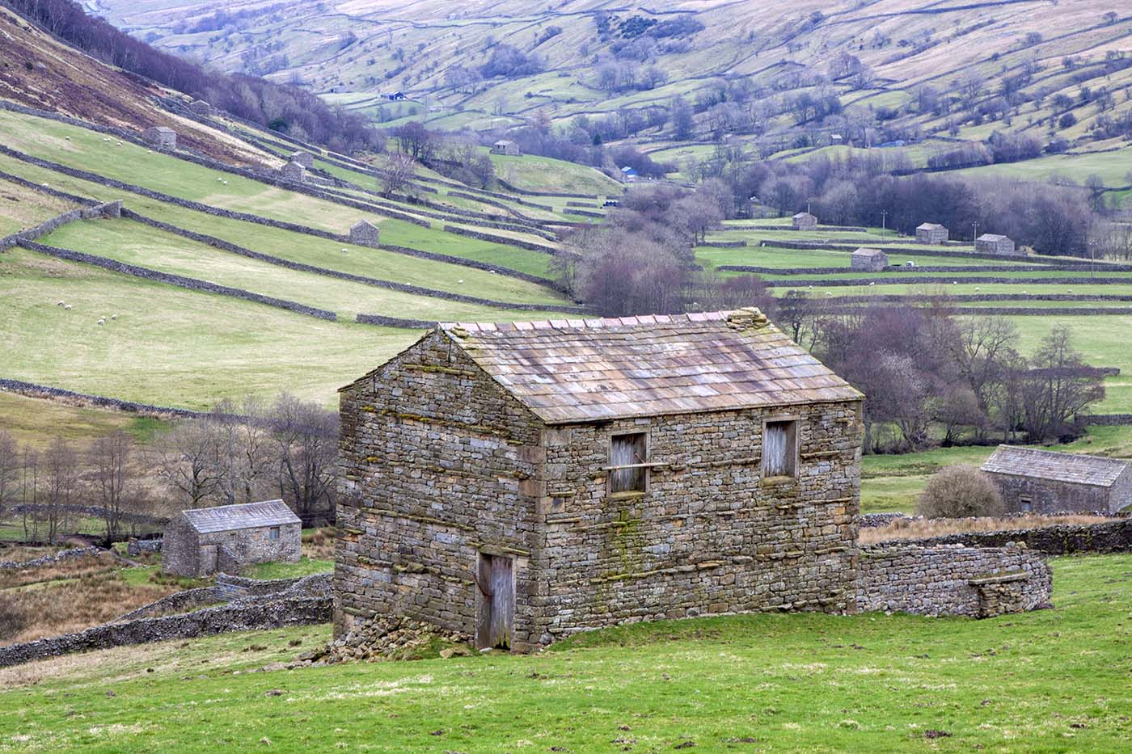 | I know the area where this picture was taken very well; there are always good opportunities for images from this spot. The way the meadows roll away down the valley and the stone barns dotted throughout the landscape is pleasantly captured here.
The Dapper Man  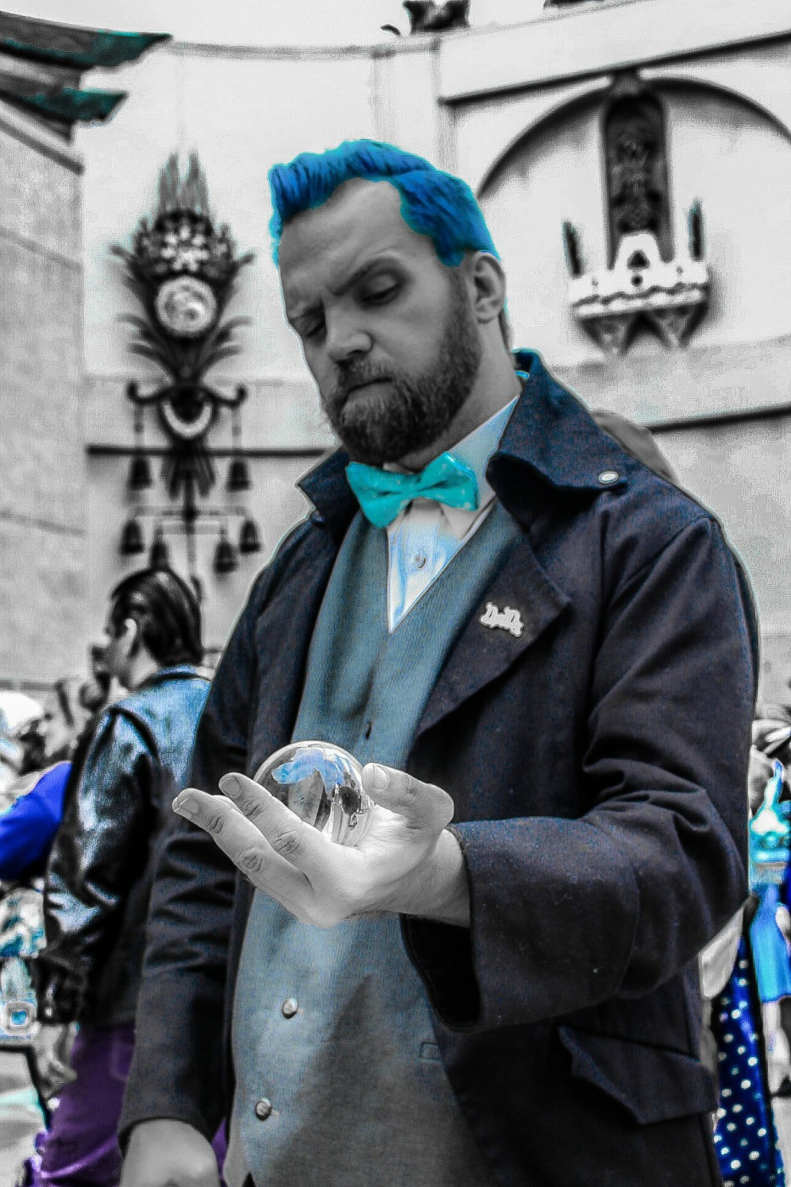 | The author has captured an interesting character here with his glass ball and added detail in post-production especially around his hand and perhaps also around his waistcoat buttons. I believe there is scope to tone down the brightness without losing the impact of the image, and more detail in his face to bring out his expression more.
The dog days of summer  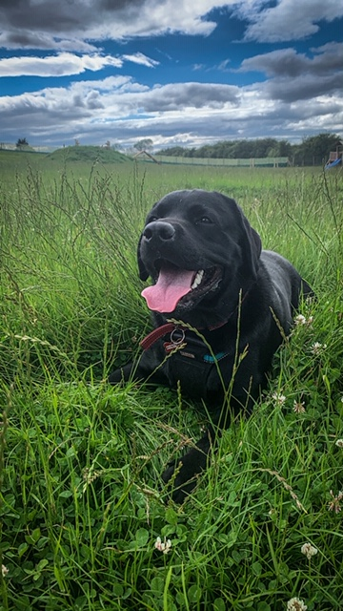 | The low angle the author has chosen for this shot works well. The diagonal lead in up the dog’s leg is a nice journey into the picture. A happy dog with a healthy tongue! Good sharpness, shadow detail and composition.
The eyes have it  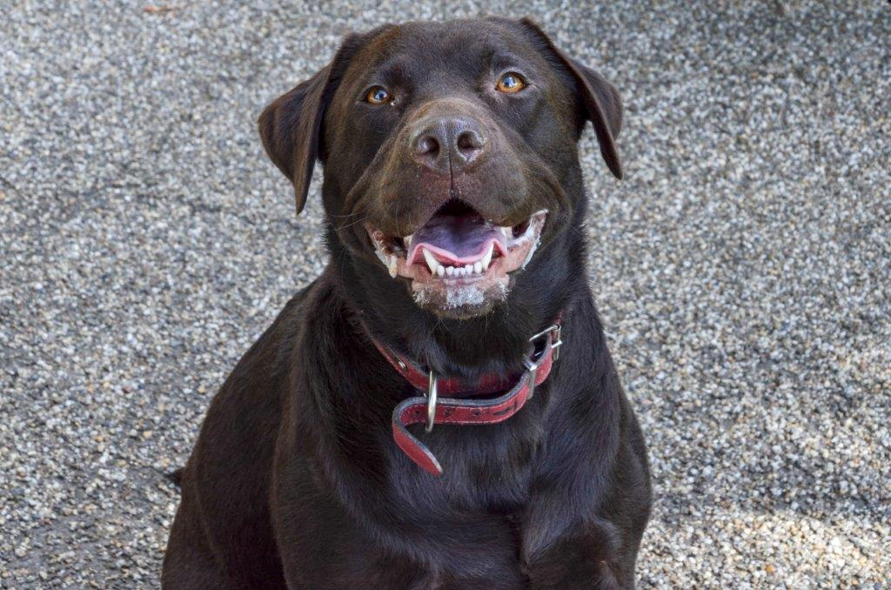 | The author has captured the dog’s attention well here for a well cropped image of an attentive animal. Sharp in the right places, good exposure and nothing intruding from the

 | background focusses your attention well on the subject matter.
The female Fab four  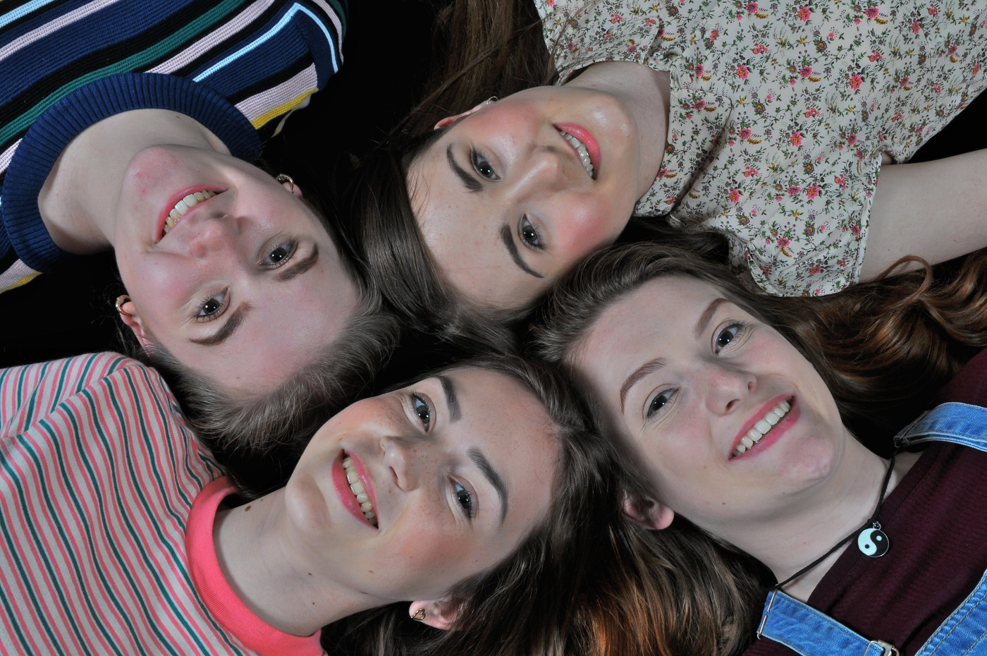 | A great idea for a happy multi portrait shot of four attractive young ladies who look like they were more than happy to pose for this moment in time. A picture you can view from any angle, frame filled nicely, good exposure and fun composition.
The long way home  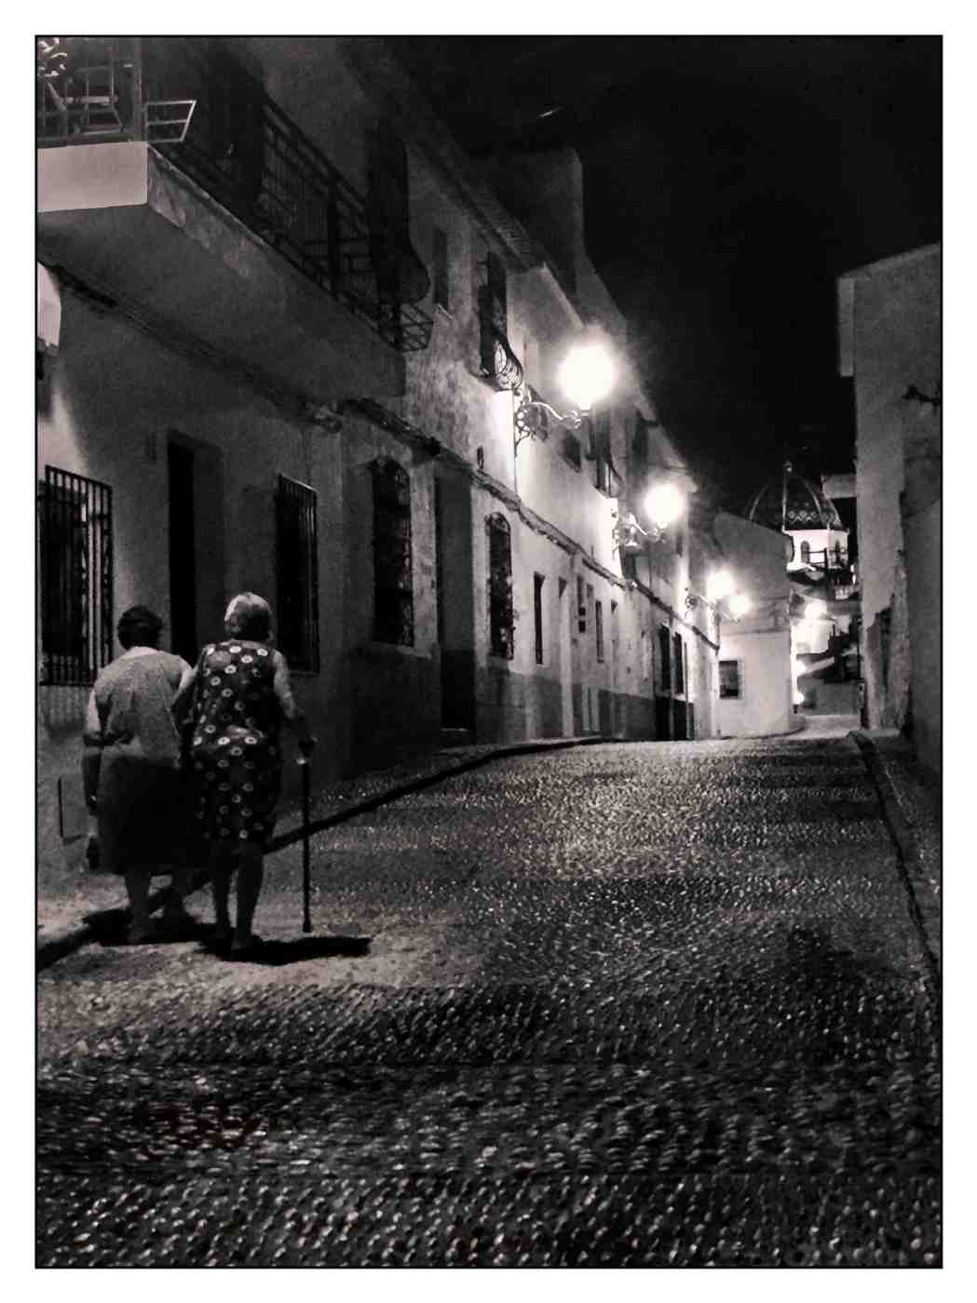 | Possibly a ‘grab’ shot taken on holiday where the author has seen the possibility of creating an image with atmosphere and with a title that conjures up thoughts as to where they have been and where they are going. Moody lighting in the right places. Low light has affected the grain, sharpness etc., but it does not detract from an atmospheric image.
The trail of the lonesome pine  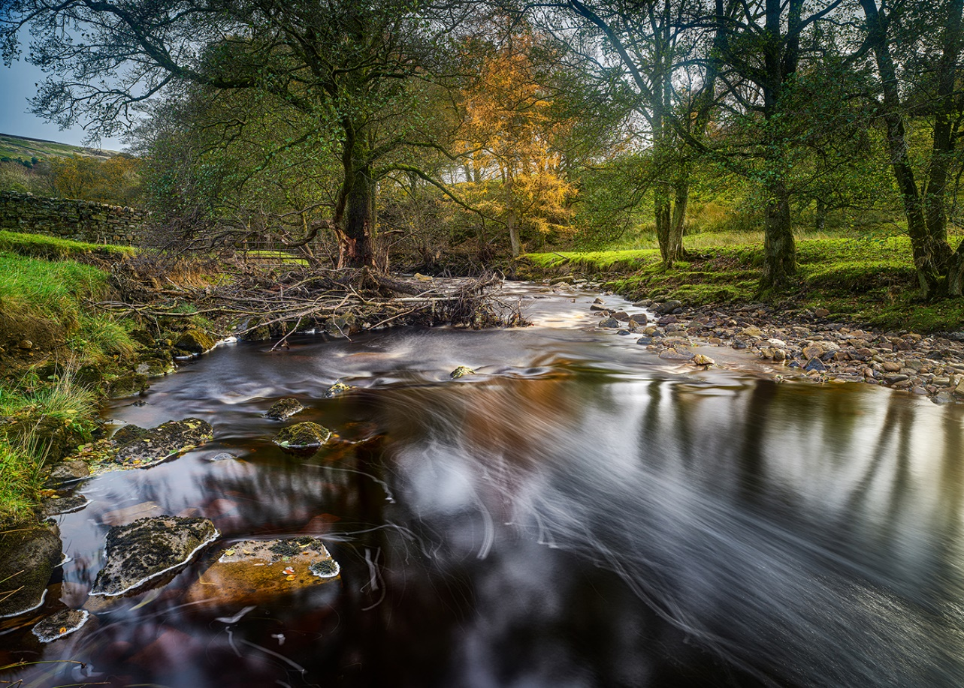 | A well composed and exposed landscape of a trees journey down a stream. The water exposure is handles well and gives a power to the image, the lighting is in the authors favour, I like the solitary conifer in the distance which impacts on the background. The light on the river bank, river rocks and wall all contribute to a good image. HIGHLY  COMMENDED
Through the archway  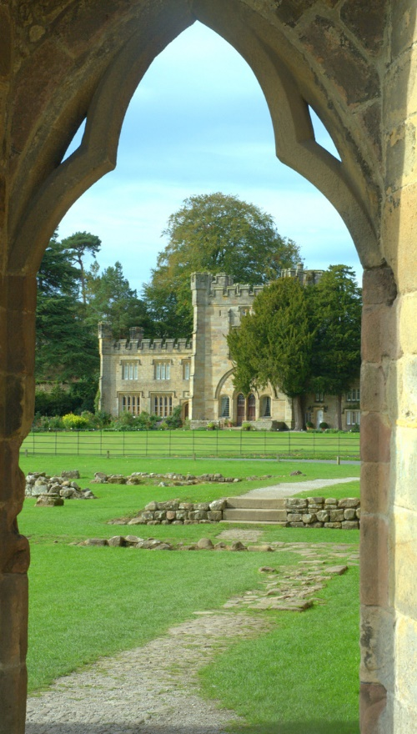 | Well framed upright architectural landscape image. Lovely detail in the arch which frames the picture well taking your eyes to an interesting old building in the background with a pleasant frieze of tree and sky. There appears to be softness to the picture. Perhaps darkening/sharpening may improve.
Undecided  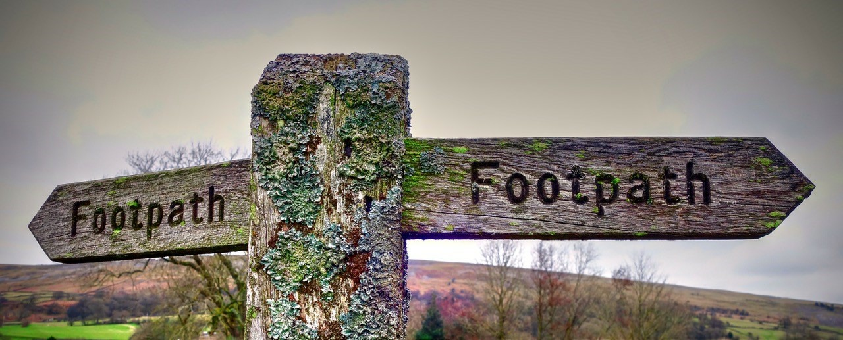 | The moss and lichen make a simple signpost into something photographic. The letterbox presentation removes anything from the surroundings which may distract. Whichever way you go, you’ll end up somewhere!
Under the Weather  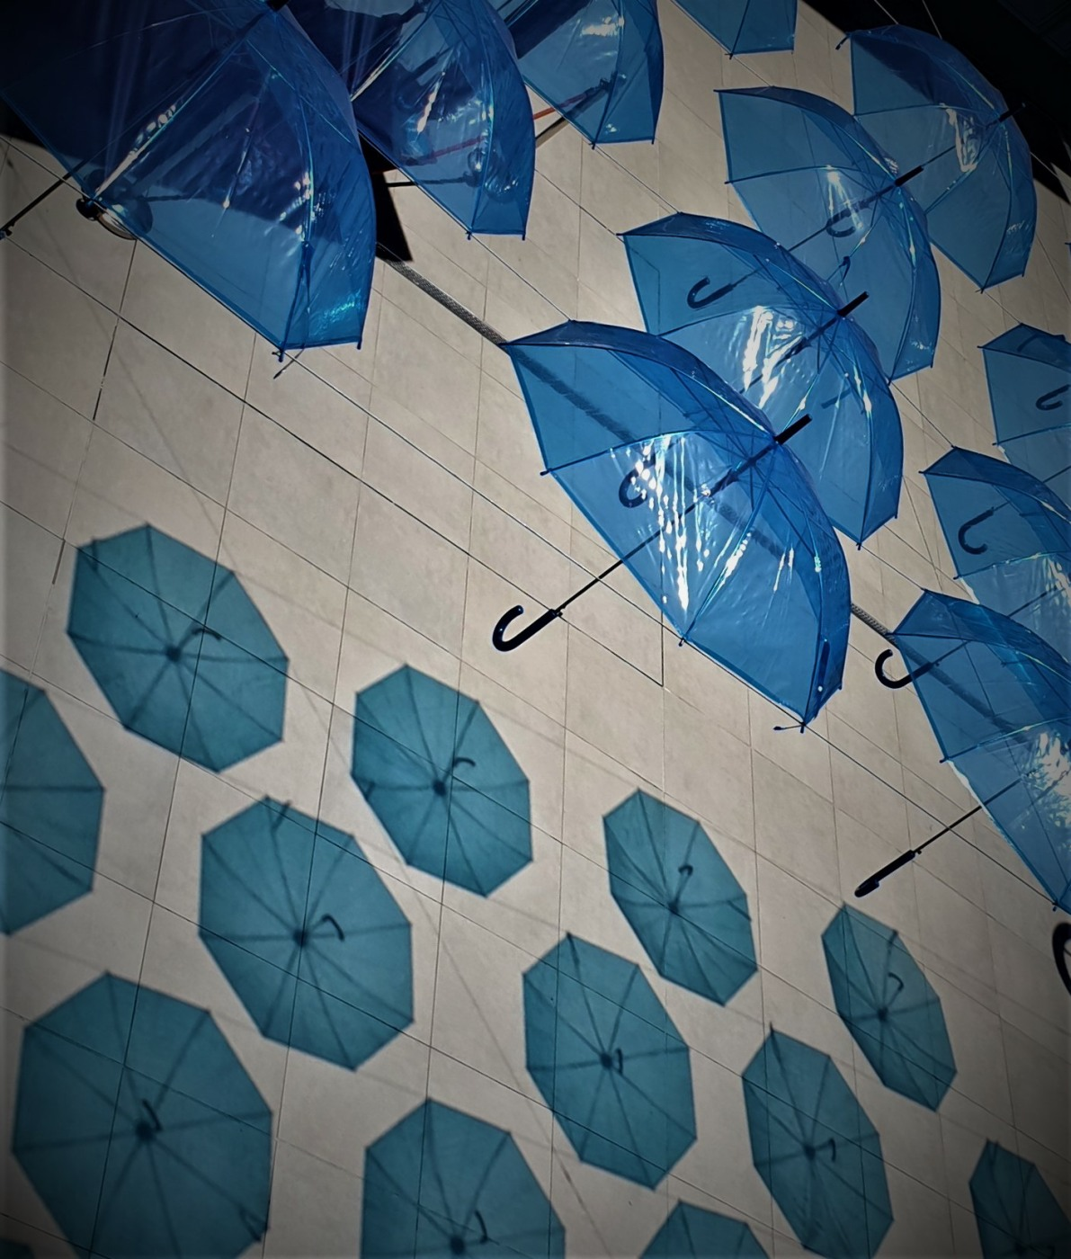 | A well spotted and constructed pattern image of blue umbrellas. The colour is powerful and impactive on the image, the pattern presented works well.
Venners steps Edinburgh  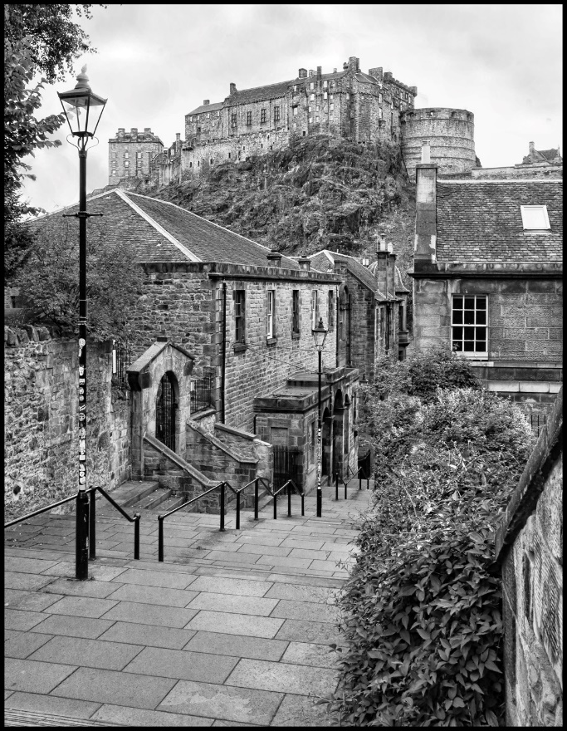 | An interesting part of Edinburgh taking you down to the old town and providing an interesting perspective of the Castle. Only the graffiti on the lamppost in the foreground brings it into the 21st C. Works well in mono, good detail and a well filled frame. Perhaps the removal of the graffiti on the lamp post would improve a bit?
Well meet again  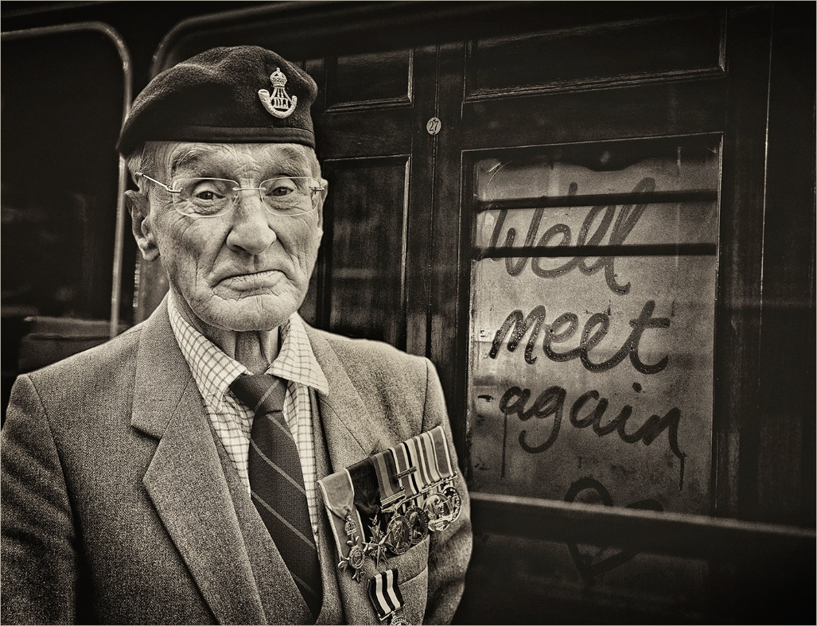 | Very appropriate as we celebrate 75yrs since VE day. A wellhandled portrait of a proud veteran with a background that

 | works well with the image. The mono effect works well, composition, framing, treatment all contribute well to this image
When will I see you again  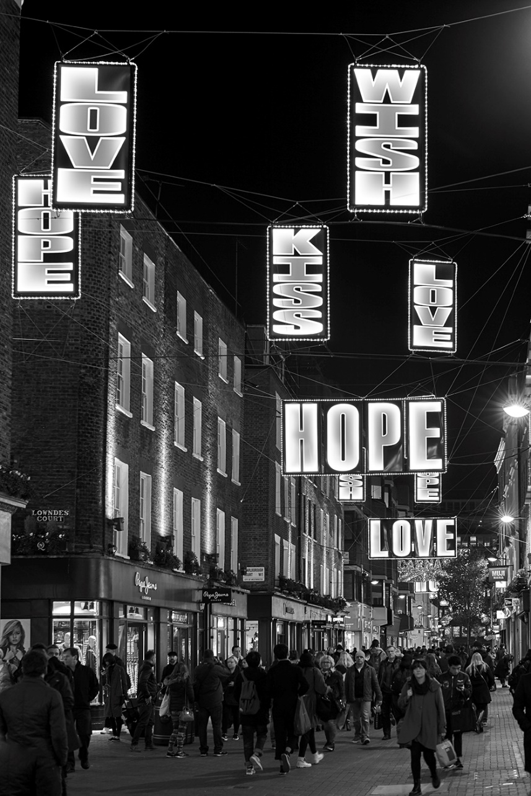 | A street night image, perhaps Carnaby Street but certainly London. The illuminated overhead messages picked up well with good exposure and detail, and captured in the pattern they represent. Good shadow detail in the figures, with a fun title.
Whiskers and fangs  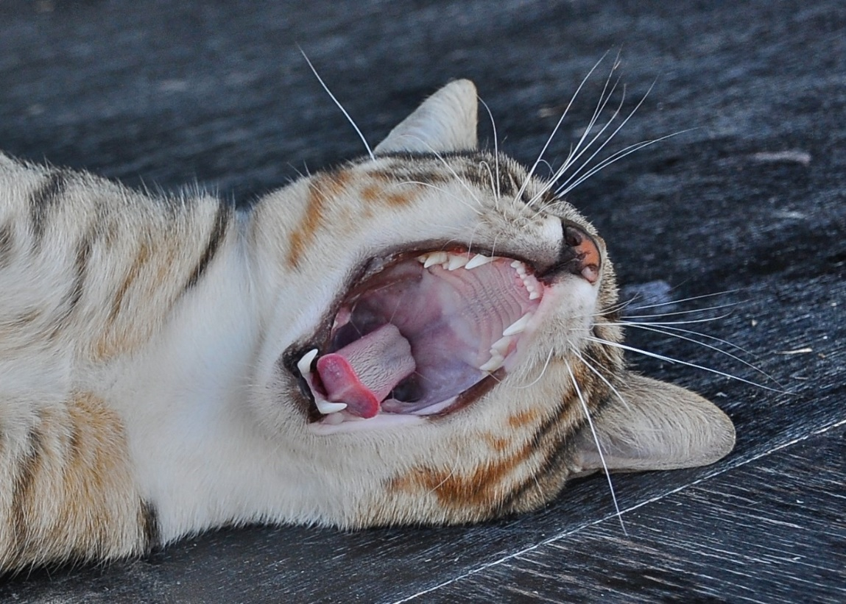 | A pet picture with a difference is the author tickling the cat’s stomach to get this reaction I wonder! Good angle with all of the detail of the title presented in graphic detail. Nothing in the picture to take your eye away from the key points. Good
Will Johns  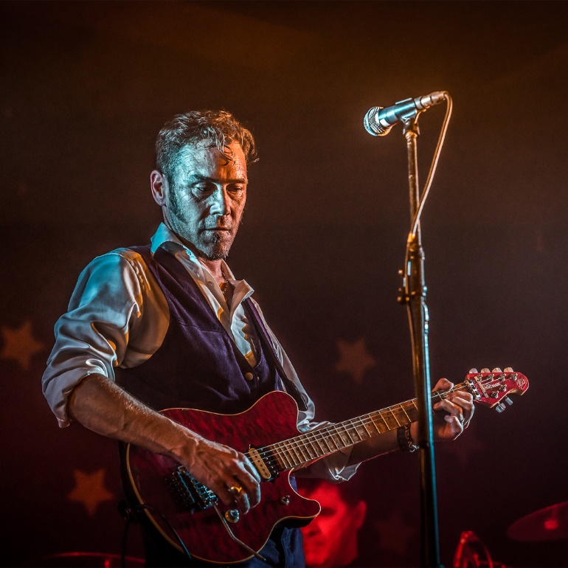 | Powerful portrait of a guitarist in performance. Good angle, lighting is excellent, expression shows that the subject is concentrating, but is that good he doesn’t need to look a the strings! Great detail throughout the image. I like the stars in the background, especially as there are just three! Only distraction is the man’s head below the guitar bridge.  HIGHLY COMMENDED
Tulip  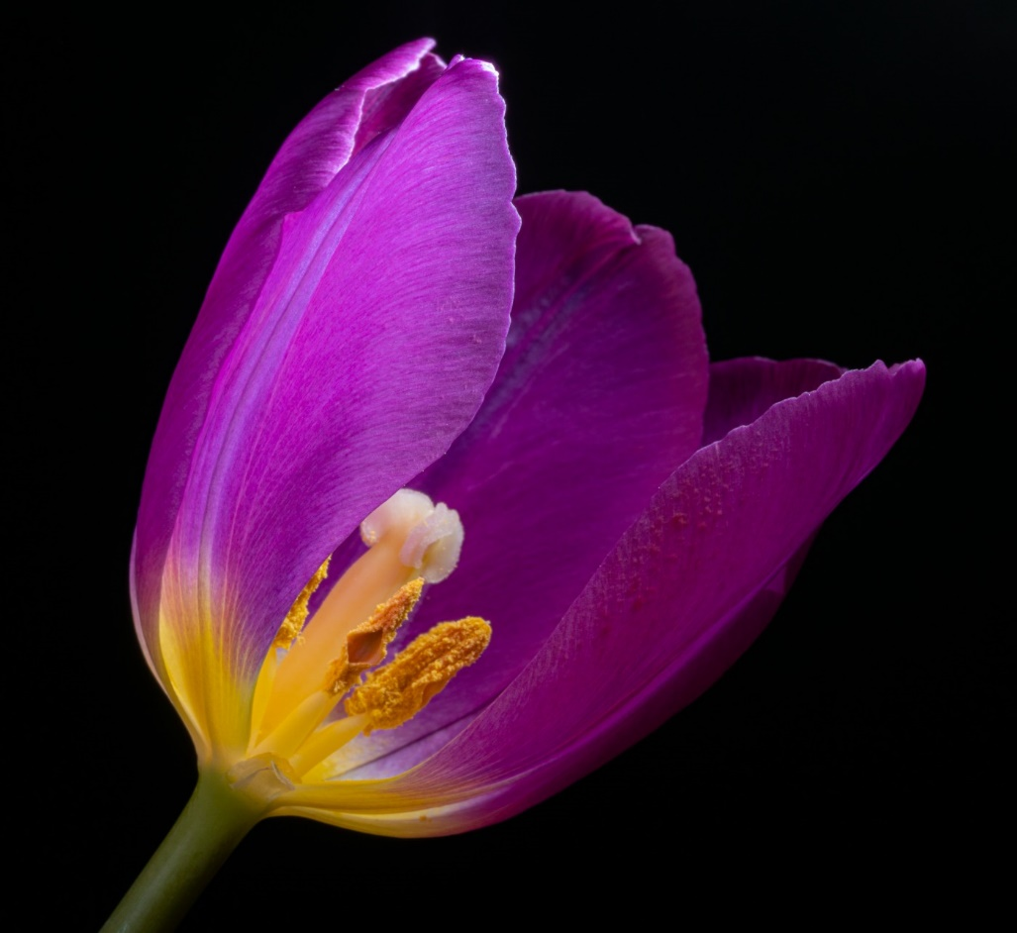 | A beautifully handled Tulip image. Good lighting, diagonal presentation, removal of a leaf to open the door into the well recorded stamen adds to the image well. Good colour and detail throughout. Well done. 3RD PLACE
Lunch  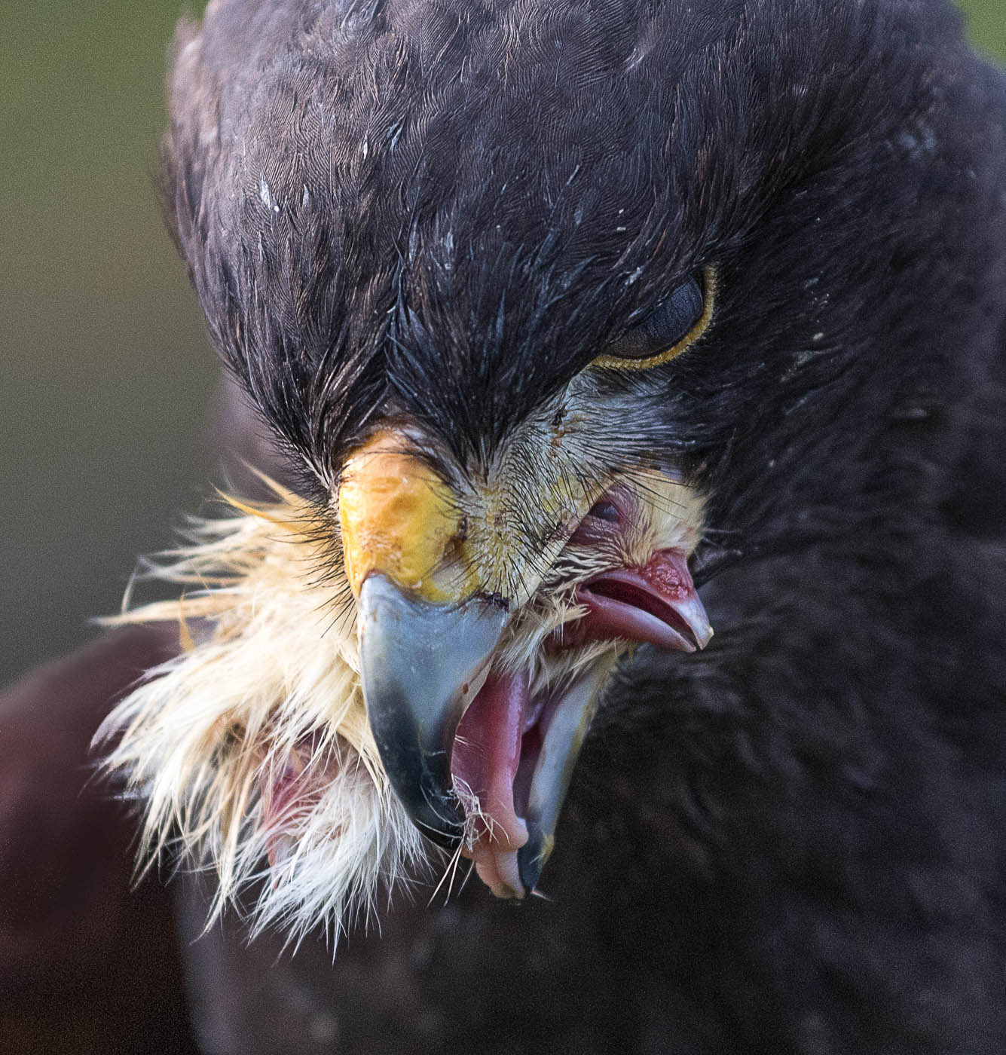 | There are some pictures you just cannot pose, or even prepare for. ‘Lunch’ is one very good example. Look at the ‘got you’ expression on the adult birds face, and the realisation of doom look in the eyes of the baby bird. It tells you everything about nature’s often cruel survival.  Photographically, its well prepared, composed, exposed and presented with nothing to distract you from the main, impactive activity. 2ND PLACE
Misty morning  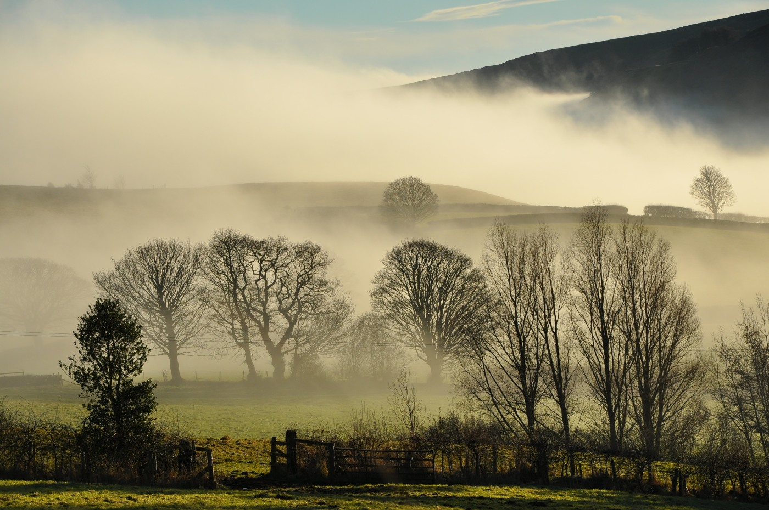 | There’s something quite ethereal about this misty landscape image. I do like the strong base of the fence with the gate open and leading you into the picture, then taking you through the levels and succession of tones up the hill. There is something to catch you eye in every part of this image, the variety of tree silhouettes, the hedgerows, levels of mist and the hill in the background. Perhaps the author has set their alarm clock to get this shot. If so, it’s clearly worked well. 1ST PLACE

