No. | Apr 2021 - Unmanipulated Comments | Position
1 | Comment:  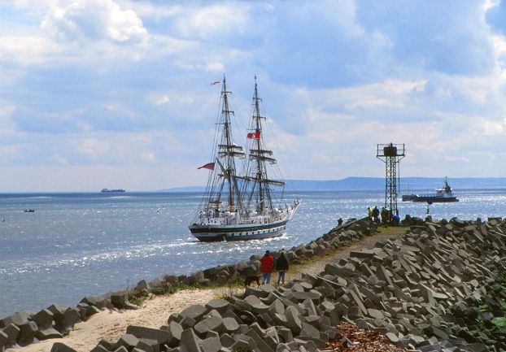  – A pretty image that works well because of the three main components – 1) a couple and their dog having a walk along the man made walkway, inner groin or harbour wall. The concrete shapes of the sea defences add a good textured base to the image. 2) The a group of men busy working or fishing and 3) the tall ship sailing home. Add the sky and shimmering sea and it makes a very interesting image.
2 | Comment:  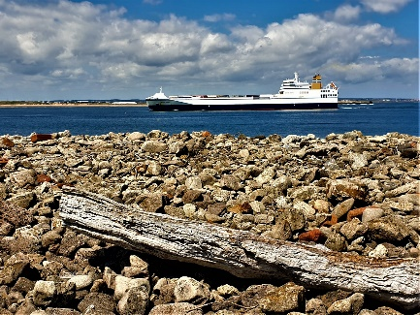  It’s a picture of horizontal sections, working from the top to bottom, fluffy clouds in the blue sky on a nice day, the ship holding the main focus and the rocks. Foreground interest with the driftwood is nicely thought out. It’s a simple picture that we would probably all take if we saw it passing before us. The photographer has put some thought behind it to make sure the crop has many areas of interest and balanced.
3 | Comment:  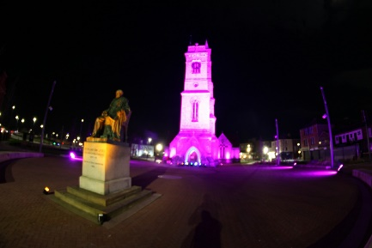  This would have been a very pretty well balanced picture of great architecture and an impressive statue as both are nicely illuminated. Great colours too with the warm yellow & pink. Unfortunately is quite blurred. I’m guessing hand held at a time when a tripod would have been handy.
4 | Comment:  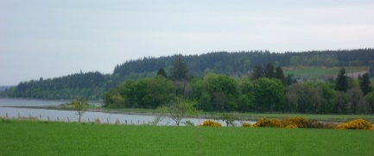  Letterbox landscape of a beautiful view that you had that day. There’s nothing in the picture to hold my attention so I just found myself looking about to see what I can find. There a good variations of greens and a touch of the yellow bottom right. Doesn’t look like the nicest day to be out and about but it tells me that you’d like any weather.
5 | Comment:  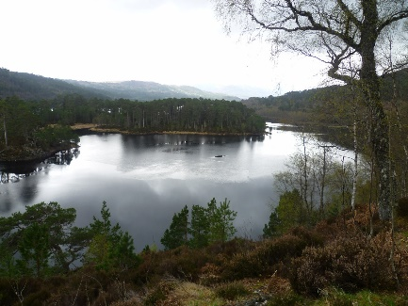  Another landscape that works really well with the high viewpoint. Looking at the tree reflections in the water on the left centre I’m guessing the rest of the lake is frozen/Icey but I may be wrong. I’m not sure that you needed as much of the sky included in this crop as everything you want to see is on the bottom two thirds but that doesn’t take away how impressive your view was that day.
6 | Comment:  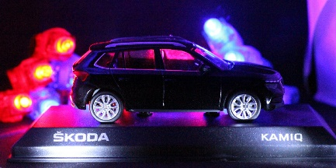  – Someone’s been creative at home, at first glance I did think you’d been into a car showroom until I spotted the lights at the back as I have the very same ones at home. Works well – you’ve highlighted all parts of the car, I appreciate the thought that’s gone into it and you might have even prompted me to buy a Skoda
7 | Comment:  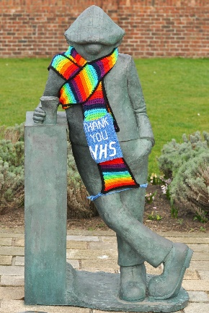  Andy Cap, the only person it seems to be able to get a pint at the pub these days. Tight crop so it’s all about Andy who’s elegantly draped in the beautiful NHS scarf that some clever crafter has made and cheered us all up with it as we walk by – I passed this myself the other day. It’s good that he can’t actually walk because he’s not going to get very far with his legs tied together. It made me feel appreciation of all workers during Covid and giggle out loud with the trapped legs
8 | Comment:  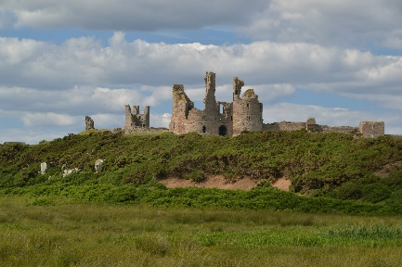  Ruins of a once impressive castle bang in the centre of the image making no mistake that’s It’s all about that. I’ve no idea where it is but I found myself wishing for time travel as I’d love to pop back to see many of these ruins that we have around the world when they were in all their glory – not for long though as I do like fast food and flushing toilets. Beautiful sky, light winds blowing the grass in the foreground, I kept trying to re build the castle parts to imagine what it was like – good image.
9 | Comment:  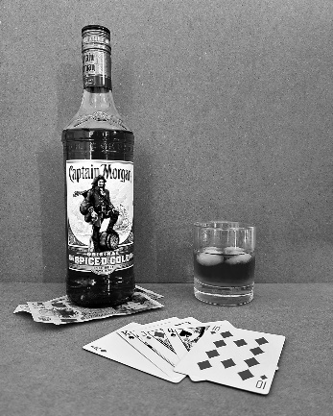  So who’s the hard core drinker and gambler among us? My partner likes a drop of spiced rum but I can never get him to play cards which is what I like to do and defiantly for money. Appreciate that you’ve been creative at home. Composition works well as does the story, I just need an invite. | HC
10 | Comment:  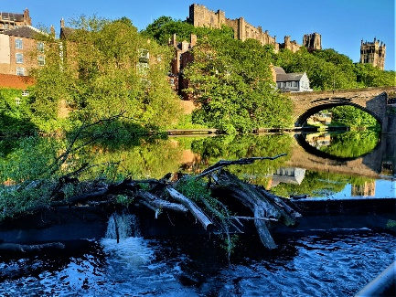  I do recognise Durham, this is like a picture of two halves with the deep blues of the driftwood & water topped by the stunning light on the greenery & castle. Add the bridge the buildings on the top left, the river & reflections there’s lots to keep the viewer interested. Good image
11 | Comment:  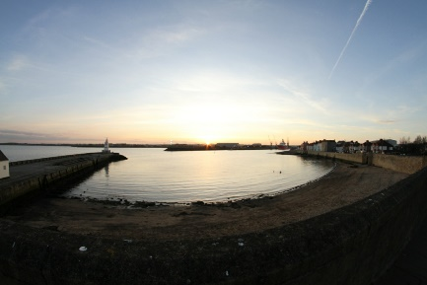  A very wide angle or fisheye headland shot. Nicely balanced with the pier and the houses, water is lovely and calm as it usually is at sunrise – and there you have the beautiful orange glow appearing. I know you’re allowed to crop in the un-manipulated comp and the image is so much stronger in a letterbox format taking off a good chunk of the sky. | HC
12 | Comment:  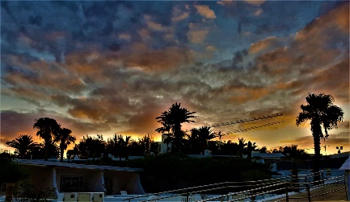  Here we have a stunning sky, a sky we photographers dream of with so much to admire from the colours blues yellows orange and the cloud formations – you’ve got some super palm tree silhouettes to add to the beautiful view tyou have before you – I don’t think for the competition you needed the bottom rails etc so for the comp id have cropped it – it’s much more dynamic when you | HC
13 | Comment:  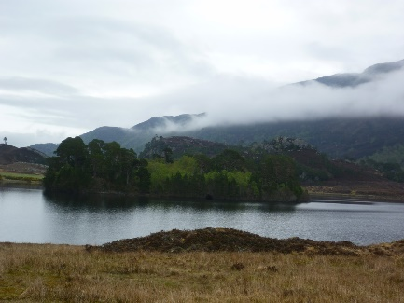  Similar to another we’ve seen so it may be the same photographer but whosever it is I like this one slightly better, same comments as before about the water, greenery but this has the added atmosphere with the cold low cloud that really adds to the scene. That little tree on the horizon centre left is super cute - cherry on the cake. | 4th
14 | Comment:  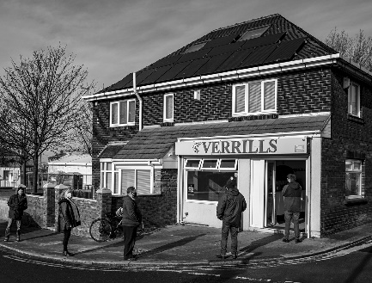  You know what I have never had fish n chips from here because I refuse to stand in a long queue. This picture is a great record shot of the current times, the Covid 2 meter distance that these hungry people are adhering too, the wearing of the masks, there’s always one character out and about and there he is at the back of the queue. Someone’s come on a bike so they need to peddle home fast to keep them warm – yes I really enjoyed this image and again works really well on Mono | 2nd
15 | Comment:  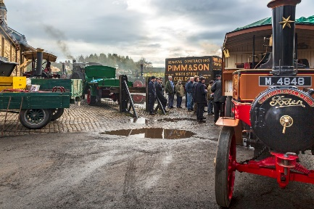  Oh what’s going on behind that vehicle I wonder, something to keep all those well wrapped up men interested – I’m intrigued. It’s a well taken image with lots of lovely colour on the motors – the reds yellows and greens – good strong primary colours on good strong engines and the likes. I enjoyed that one. | 6th
16 | Comment:  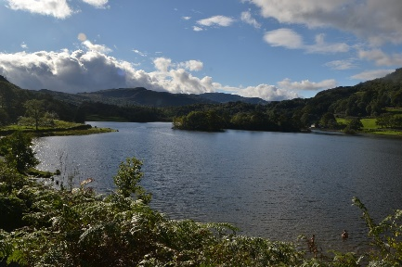  Another beautiful lake, someone out on what I’m sure was a lovely walk. Nice viewpoint and it has everything you’d expect the sky, water, hills in the background and foreground interest – but look bottom right – the added gem of a family swimming. They brought the picture alive for sure.
17 | Comment:  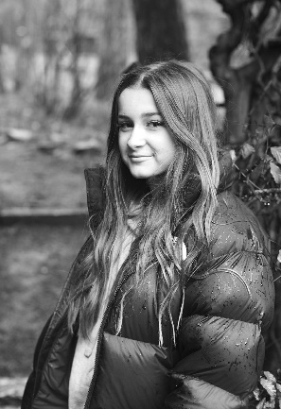  A beautiful portrait, I doubt she would take a bad picture. Soft mono tones throughout so it works really well – because you don’t really want her pretty face to be in competition with any nice colours. Lovely connection between the eyes and the camera. In the woods when it’s raining so respect – it’s a v good portrait. I bet she loves it | HC
18 | Comment:  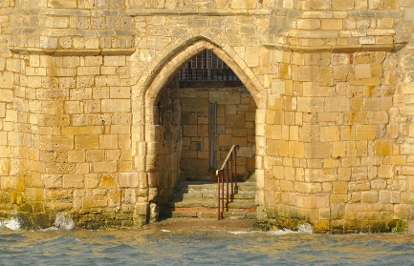  I’m new ish to Hartlepool so when I first saw this I thought someone’s been to Venice then realised where it was on the headland. Tides in, not too choppy, light is lovely, stonework looking textured and interesting with all the stone shapes and construction. I looked at it for a while waiting for a lady to walk down the steps in an old fashioned bathing suit with a rubber ring around her waist. No I’ve not been drinking that spiced rum.
19 | Comment:  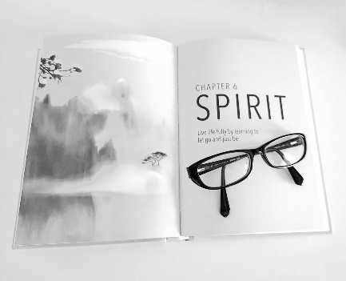  This was both interesting, a very thought provoking message for us all to digest and consider – are we all letting go and living life? Certainly made me realise that maybe I do worry about the non-important things and should like it says ‘Let go’. I needed to look hard to see if the glasses where a picture on the page or your glasses so you made me work harder than other members It’s a difficult image to take, as in the background and book are variations of white but you’ve still managed to keep all the book edges visible. Well done. | 1st
20 | Comment:  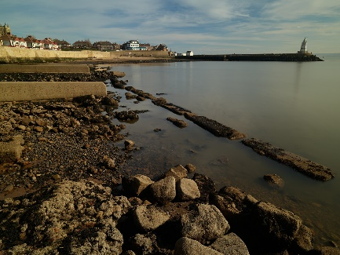  A wider view of the headland this time with the tide right out. Really liked the composition, the lead in lines of the water’s edge and stones, groins then up to the houses balanced with the pier. Sky has some interest and all in all a well thought out image | 3rd
21 | Comment:  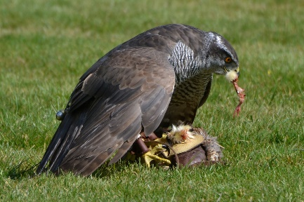  Oh a change, some blood & guts and a bird of prey. The picture has been handled really well, low viewpoint in line with the bird’s eye, nothing in the picture distracts from the bird, I can see every feather, the excellent detail and the texture. It’s a bright day and even the white on the neck has been handled well with no burn out. Great image. | 5th
22 | Comment:  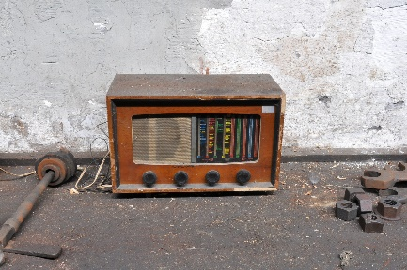  Every picture tells a story so who had a radio like this, and if you, parent, grandparents did I’m sure it conjures up many good old memories, The tools and bolts at the side make me think it’s in a workroom of sorts but id really of liked a close up of the radio itself – just to read the stations and information on the front panel that we see there. These days can’t imagine life without my all singing and dancing Alexa but in them days they couldn’t imagine life without this old radio
23 | Comment:  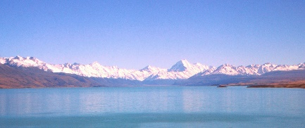  – A very pretty pastel sea/lake scape as I’m not sure where it is. The snow-capped mountains are the main feature and how beautiful they look. The picture itself is very soft and I needed something to pop/keep my interest but I still enjoyed it. The letterbox format worked perfectly.
24 | Comment:  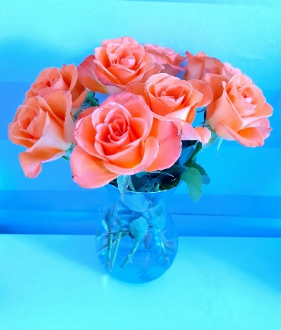  Delicate but beautiful colours that work really well together – the peach, blue and green. I love roses and these have been taken very well – the petals show interesting detail and nothing is out of focus – a nice indoor project. | HC
25 | Comment:  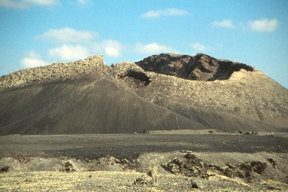  Well I don’t recognise where this is and I can’t say it’s pretty like some other landscapes but no doubt it’s interesting. I looked at the image for quite a white trying to work out the scale or what it was – I’m guessing it’s an old volcano somewhere abroad but the author is probably chuckling because it’s a local slag heap or something. Nice sky and interesting but it left me wanting more info.
26 | Comment:  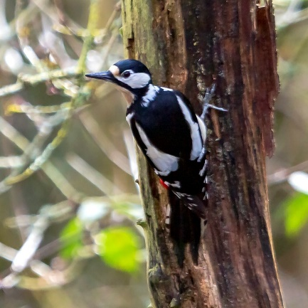  I’m not knowledgeable on birds so I had to ask my other half who said he thinks it’s a ‘pied woodpecker’ it’s a nice subject, a nature action shot, I think he/she knows you’re there if not its being very cautious as it should be. I found myself looking at its head a lot because the rest was quite soft – but definitely a well caught image.
2 7 | Comment:  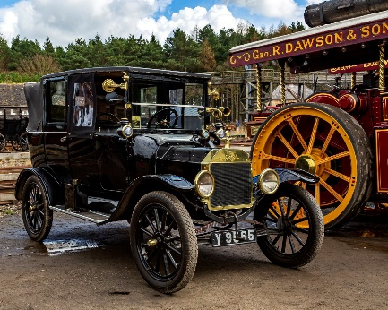  I do like a classic vintage car, whenever we go to country fairs or similar where these are displayed and paraded I come home with far too many pictures and all similar. It’s a beautiful machine, put this side by side with a popular modern day car and I know what I would choose. Even though the backdrop is a bright red and yellow Dawson engine the car still holds its own - I spent quite a while looking at all the parts, horns, badges, lights etc

Results Unmanipulated
1. 19
2 14
3 20
4 13
5 21
6 15
HC’s. 17 / 24 / 9 / 12

