Un-manipulated pics

Image 1.

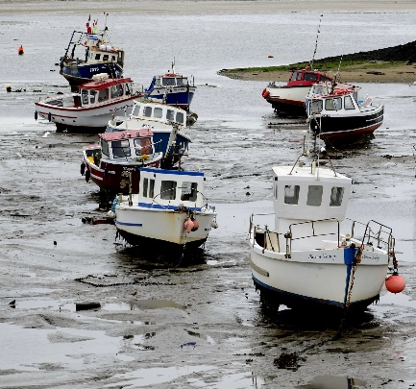
Nice image of boats at low tide placed diagonally through the image.

The weather may not have been the best that day leaving the image a little flat

Image 2 2nd

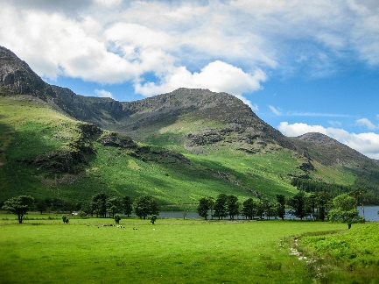
A great image of the lakes, colours are vibrant which contrast with th shadows from the clouds
Sharp throughout with interest to lead you through the image

Image 3 4th

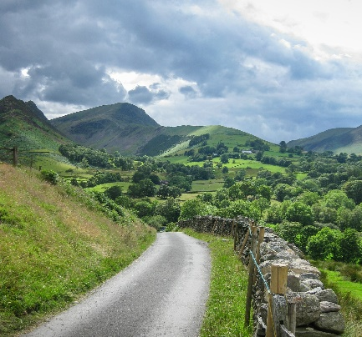
A road to where, the road leads you through the image and up,over the hill tops.
A moody sky warns of storms to come – great image.

Image 4

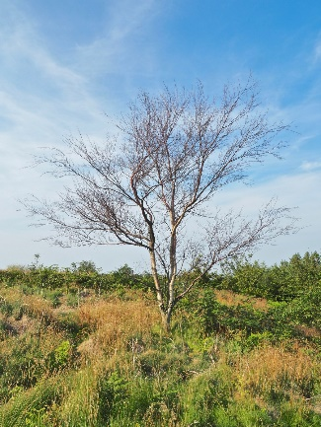
A lonely tree in a field. Nice contrast in the colours of the field.

Image 5 3rd

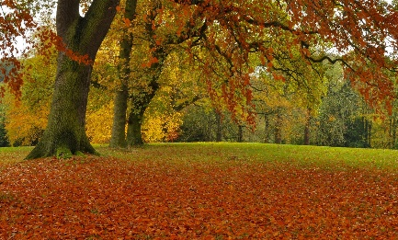
A lovely autumn scene full of seasonal colour
The bursts or orange lead the eye around the image

Image 6

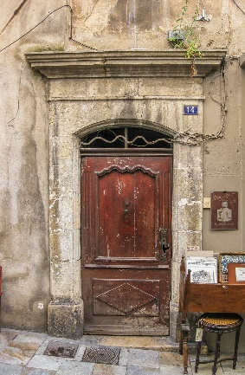
A nice image of a door with lots of interesting features.
The book stall to the right

Image 7. HC

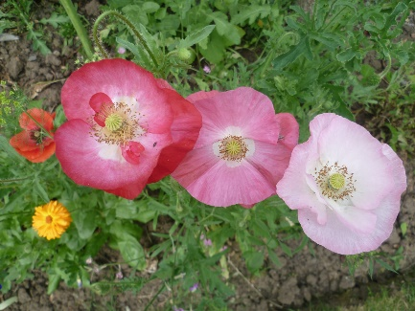
Pretty poppies , colourful and in focus. Well cropped with enough background to give contrast

Image 8

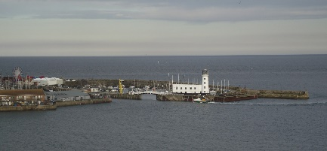
A nice image of a harbour, but the colours are flat
Could possibly benefit from losing the left hand side and some of the sky to make the lighthouse the forecast.

Image 9

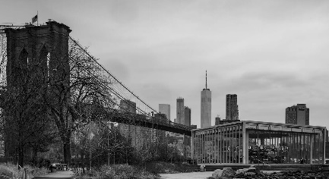
Interesting view of the Brooklyn Bridge And Janes Carousel
A nice monochrome looking towards Manhattan

Image 10

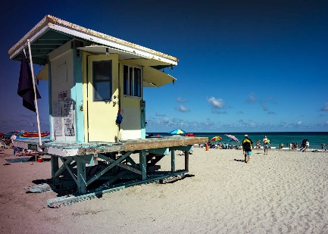

A lovely beach beach hut and welcoming water but unsure of the colour cast to the left of the image.

Image 11 5th

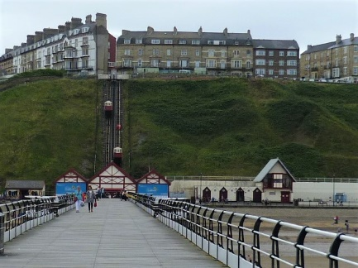

A different view of saltburn from the pier towards the lift.
A perfect line along the pier and up the lift track
The colour is A little flat but apart from that a nice image.

Image 12 1st

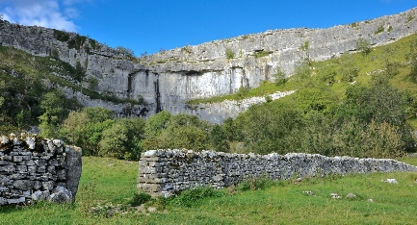

A great image which draws you in and around the image – great colours with interesting cloud formations

Image 13
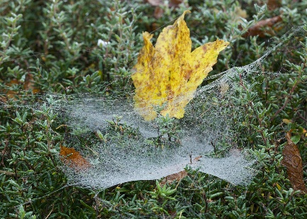

An interesting image a dewy Spiders Web, but no ones home.

The yellow leaf is a little distracting and draws the eye from the web.

